SAS Viya + SAS Viya Workbench Overview

SAS Guided Demo

Purpose
This SAS Guided Demo provides you with an overview of the wonderful, powerful world of SAS Viya. From no- and low-code environments to cutting-edge tools just for coders and developers, SAS Viya is a great place for anyone to start – or resume – an analytics journey. In this activity, we’ll provide you with a broad overview of some important tools in the SAS Viya ecosystem – and then provide you some next steps to continue your learning.

Overview
- This SAS Guided Demo provides a quick overview of two great SAS software platforms available to academics: (1) SAS Viya and (2) SAS Viya Workbench
- In SAS Viya, you’ll see:
  - How quickly SAS Visual Analytics turns data into insights
  - How quickly we can get from data to completed models in SAS Model Studio
  - So, speed, speed, speed in SAS Viya… and once of the key is the embedded AI agents in the SAS Viya tools
- In SAS Viya Workbench, you’ll see
  - How coding gives you the ultimate flexibility in your analysis
  - How WFL provides you an ultra-fast SAS platform to run both SAS + Open-Source code
- This guided demo hopefully gets you interested in one of FOUR learning paths, depending upon what questions you’re still asking yourself after we finish:
  - Still confused and want to learn more about the SAS Viya ecosystem?
    - Take our SAS® Viya Overview course
  - Like dashboarding and SAS Visual Analytics?
    - Explore SAS Visual Analytics 1 for SAS® Viya: Basics
  - Like predictive modeling and machine learning in a low/no-code environment?
    - Machine Learning Using SAS® Viya® is a great option!
  - Finally, love coding in a multi-language environment and want to explore SAS Viya Workbench more?
    - Modern Data Science with SAS® Viya® Workbench and Python is perfect for you!

Backstory for this Demo
- Let’s play pretend.
  - You are a newly hired Data Scientist in the Customer Retention Department at Styled and Sophisticated Enterprises (SASe)
  - SASe provides personal stylist services, offering premium clothing boxes through a subscription model.
  - Your goal is to analyze customer churn to better understand which customers are on the brink of canceling their subscription service

Software
This SAS Guided Demo uses SAS Viya for Learners 4, version 2026.03LTS. Other versions can be used, but some screenshots will differ.

Prerequisites
Some experience using the SAS Viya ecosystem is helpful but not required.

Table of Contents
SAS Viya + SAS Viya Workbench Overview 1
SAS Guided Demo 1
Purpose 1
Overview 1
Backstory for this Demo 2
Software 2
Prerequisites 2
Uploading Data Into SAS Viya for Learners 4
Understanding Your Data in SAS Visual Analytics 6
Modeling in SAS Model Studio 27
SAS Studio in SAS Viya (Steps and Flows) 33
Copilots within SAS Viya 39
Using Open Source in SAS Viya (Jupyter Notebook) 41
SAS Viya Workbench – Bonus Information 44
Modeling in SAS 48
Modeling in Python 56
SAS Model Studio, Revisited + Expanded 64
Wrap-Up and What’s Next. 72

Uploading Data Into SAS Viya for Learners
First, we will need some data.
- As such, log in to SAS Viya for Learners.
- Once in, you’ll land on the SAS Landing Page, which is your starting point in SAS Viya for Learners. It will look like the following:

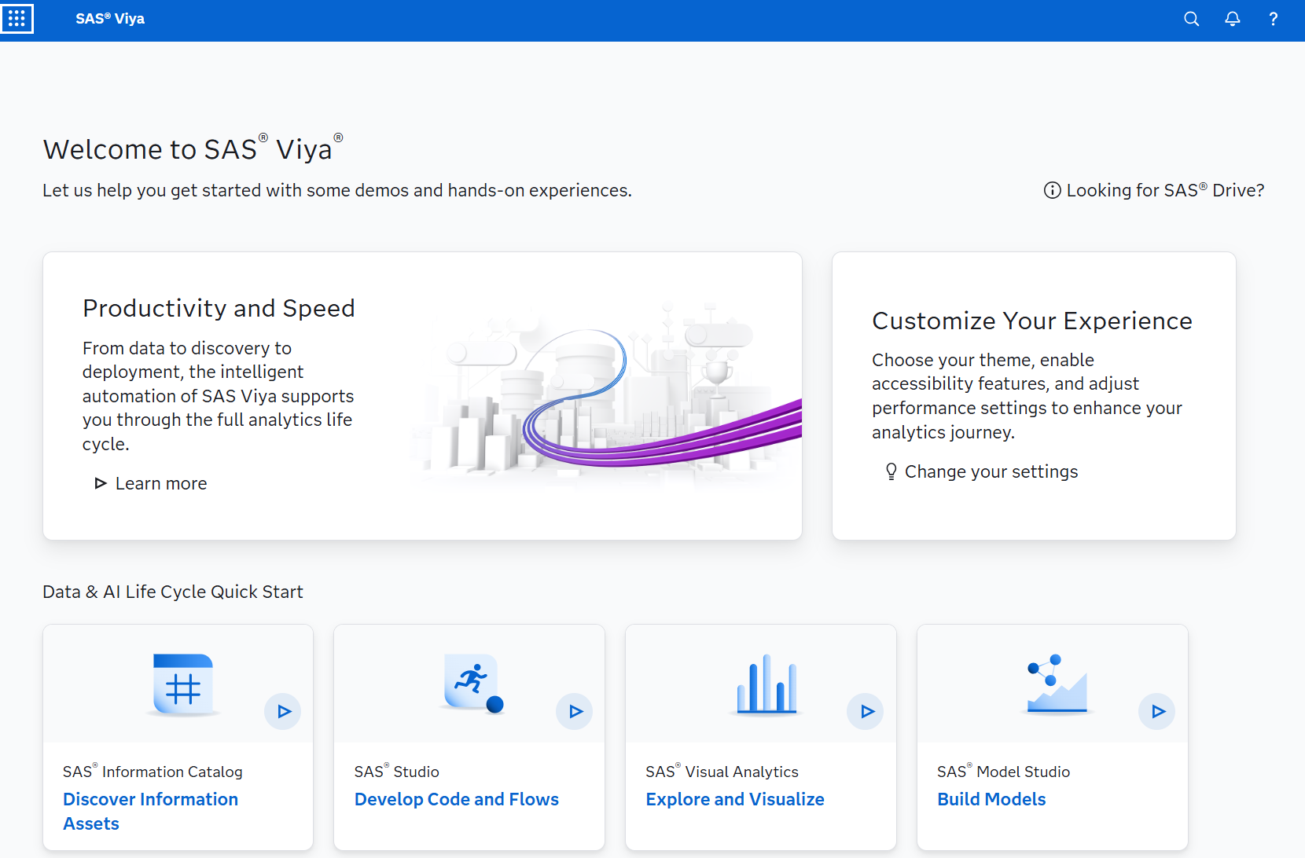

- But we won’t linger here long – as we want to get right into Manage Data. From the top left corner, select the Applications menu ___ and click Manage Data from the Analytics Life Cycle options.
- Click that Import button in the upper left. Select Local Files. This will open a file browsing window on your machine. Locate and select the data set that you wish to upload into SAS Viya for Learners. Click Open.
- The import exchange will open and allow you to select where to place this new data set. Click the cloud icon at the end of the Location(Library) text box. Expand the cas-shared-default folder and select CASUSER. (You will note that your login credential will appear in parentheses next to the library name.) Click OK.
- If you have uploaded this file previously and wish to replace the file you can select the radio button that says Replace file.
- Click the Import Item button at the upper right.
- Once successfully imported, click on the Source button in the upper left. Expand the cas-shared-default folder and select CASUSER. (Two forms of our data set appear in the list.)
- Click the data set version with the lightning bolt present in the icon. We can now explore aspects of the new data as well as draw up sample data for viewing.
*Special Note: Notice the Actions button in the upper right when you are viewing the uploaded file within SAS Data Explorer (Manage Data). Clicking this button will present a dropdown menu that will allow you to proceed directly to Visual Analytics or to Model Studio with this current data set as the focus.

Understanding Your Data in SAS Visual Analytics

A good data adventure often starts with software.
- From the top left corner, select the Applications menu ___ and click Explore and Visualize from the Analytics Life Cycle options.
- And the Explore and Visualize landing page awaits. Click that New report button in the upper right corner:
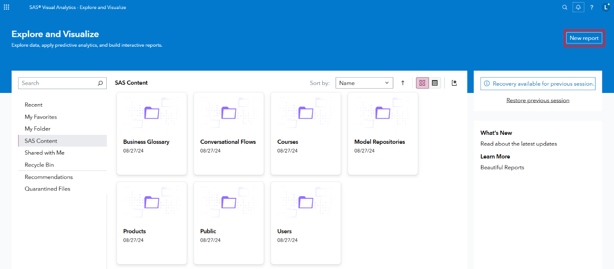
- Now you’re really in SAS Visual Analytics. Look for the Add data button, as it’s always great to start a data adventure with a data set:
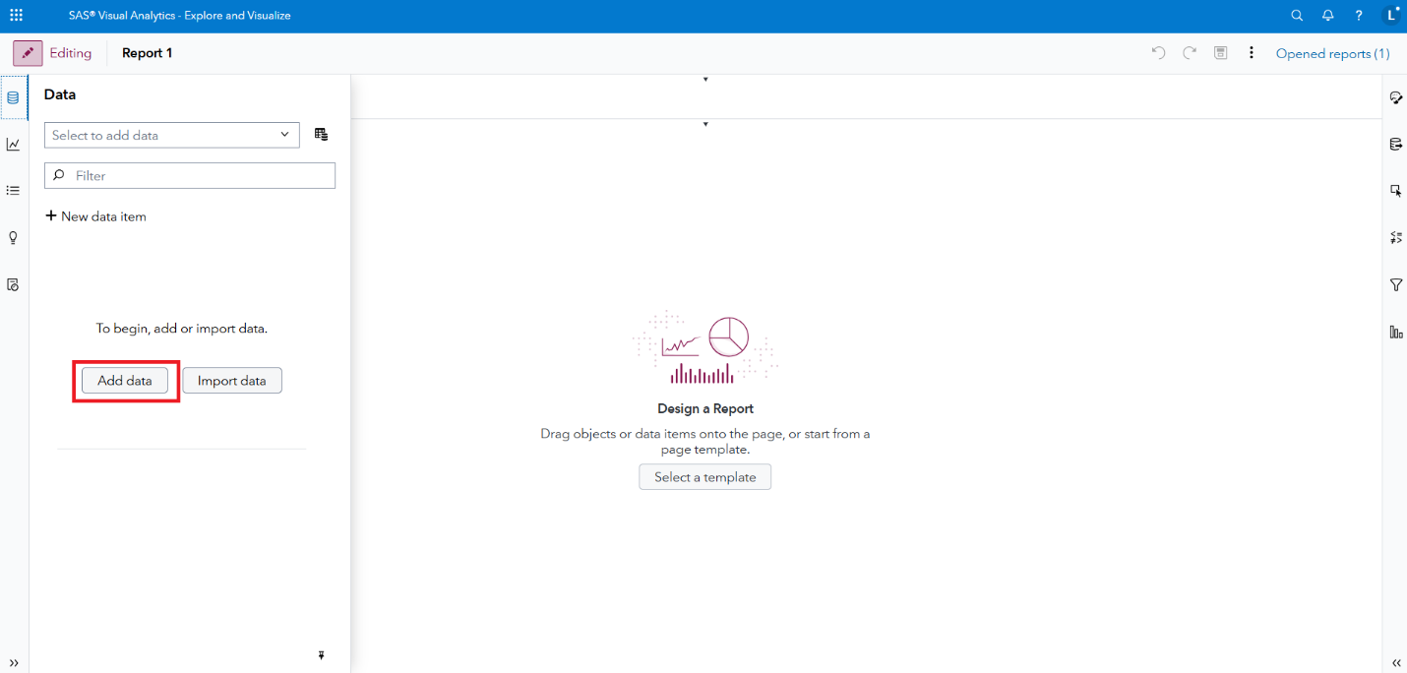
- Click Add data. And – in the Choose Data window – locate the Search all data bar:
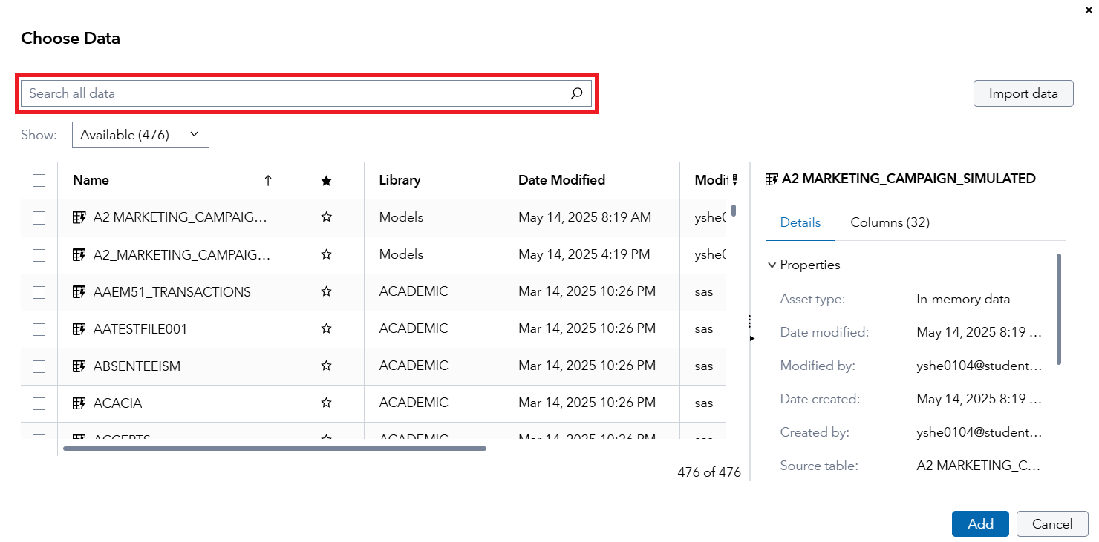
- Type (or paste) customer_churn_ml_train_final into the search bar. The press Enter. You should have a smaller number of datasets to process:
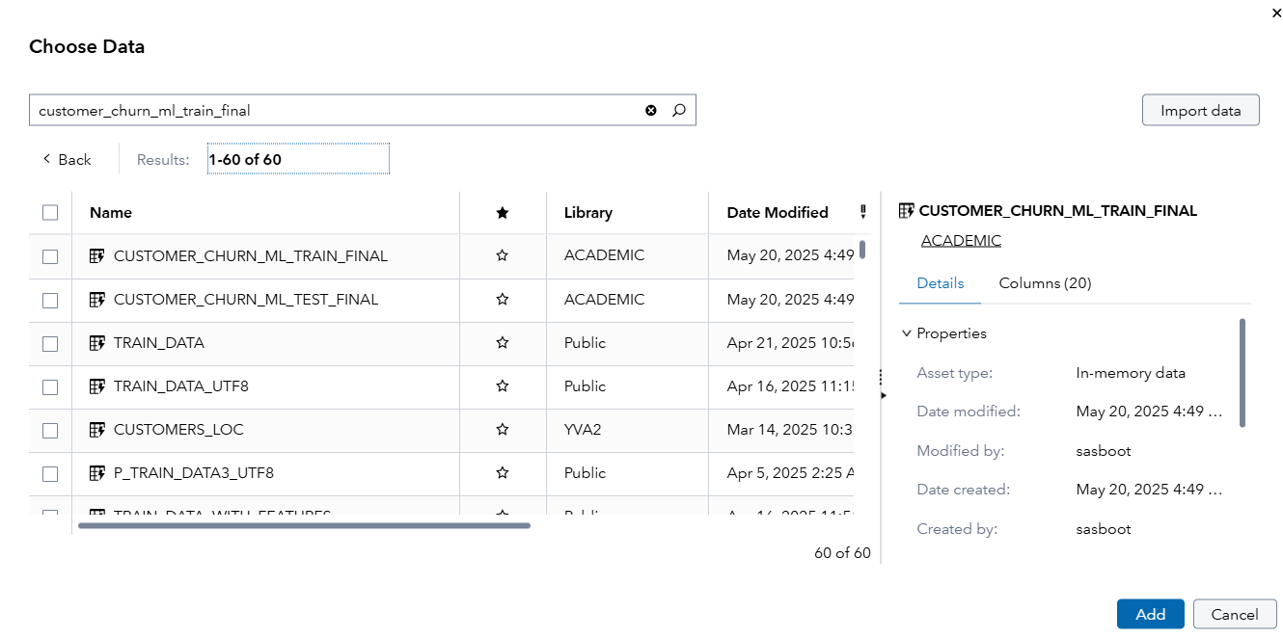
- And the first file in the ACADEMIC folder is perfect. Select that data set:
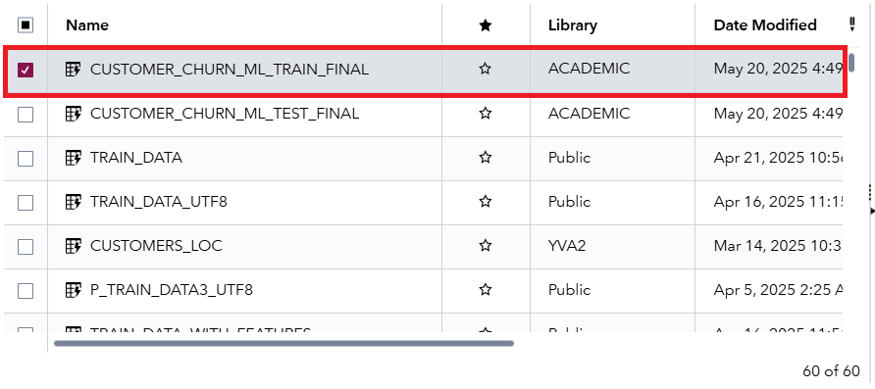
- Then click Add. You now have data in your VA report:
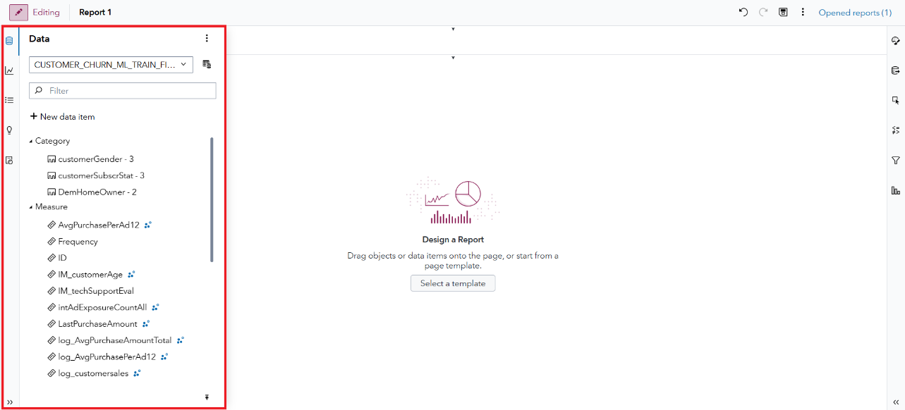
- Go ahead and click that Pin pane button, just to make navigation easier. It’s found in the lower-right corner of the Data pane, and looks like this:

- Ready, set, dashboard! Are you ready to get to know your data a bit better with some dashboarding? Well, let’s do it! A good place to start with a new data set is to look at the underlying values. So, from that Data tab, find the Data source menu. Then navigate to View customer_churn_ml_train_final source table, like so:
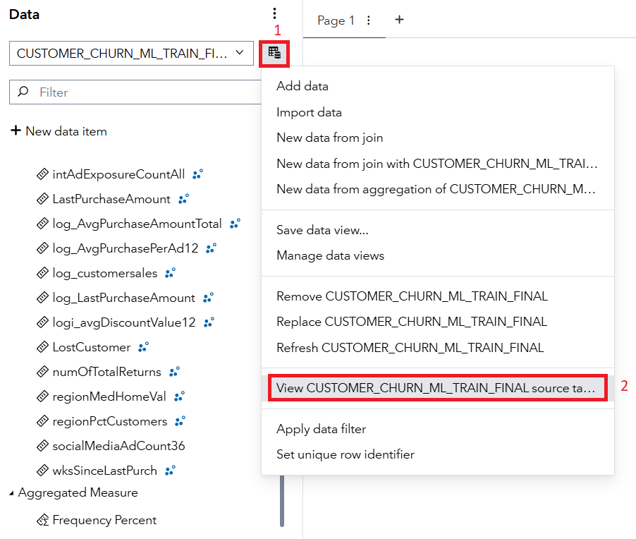
- A tabular table awaits!
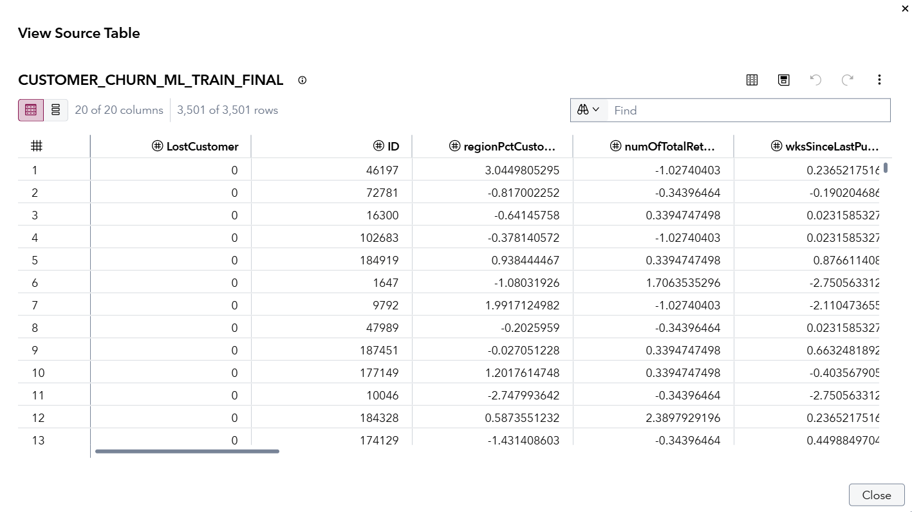
- And we can see a couple of important things quickly. To start, our data set is just 3,501 rows and has 20 columns. LostCustomer is our outcome of interest – as it is a binary variable which reveals whether the customer canceled their premium subscription box at SASe (1=yes and 0=no). After the unique customer ID, ID, we then have several variables which help explain the customer’s behavior. Explore a bit to get to know the data a bit better – then click Close when you’re satiated.
- Now let’s create a couple of dashboards. But before getting there, we need to save – and save often in SAS Visual Analytics! How to save? Well, it’s the old-school floppy disk found in the upper-right corner, here:
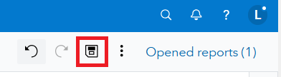
- The project Name can be something like SASe Customer Churn. Then just click Save to place the project in My Folder:
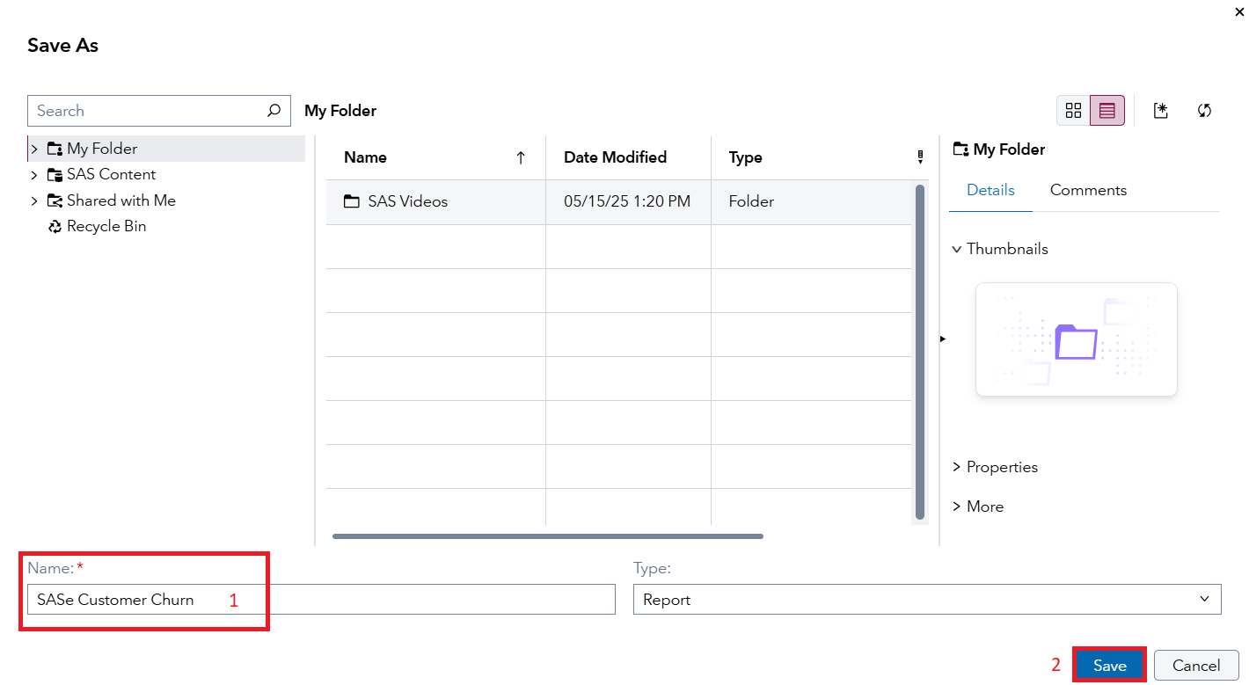
- The first page in our dashboard will be a bunch of descriptive plots to better understand our data. And we’ll leverage our first AI agent – the + Auto chart tool – to produce some quick charts. Ready? If yes, search for LostCustomer. Do you see it under Measure?
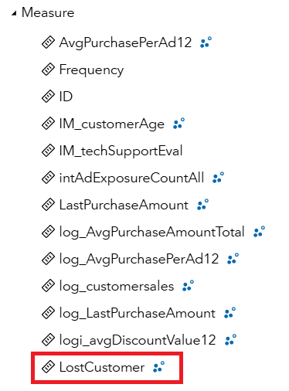
- Well, I do. But we want it as a yes/no variable in our model, rather than a continuous variable. But the fix is easy. Just right-click on LostCustomer and select Convert to category:
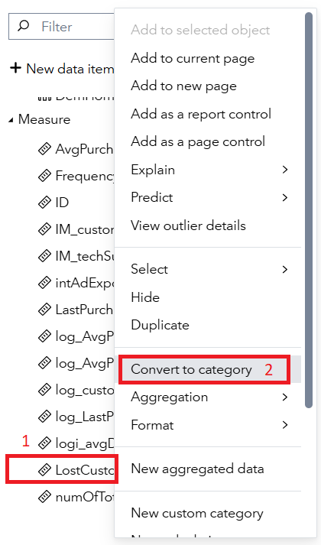
- LostCustomer will now show up under Category, with two values:
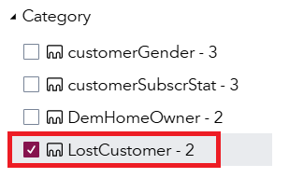
- Next, drag and drop LostCustomer onto the canvas, like so:
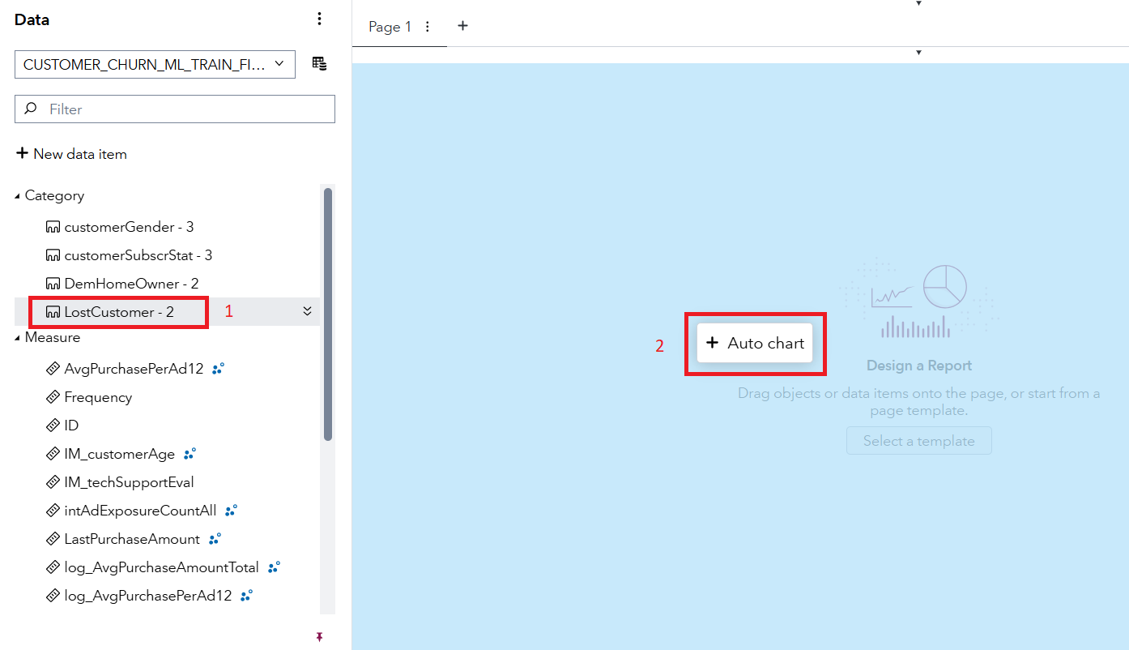
- And you’ve got a bar chart!
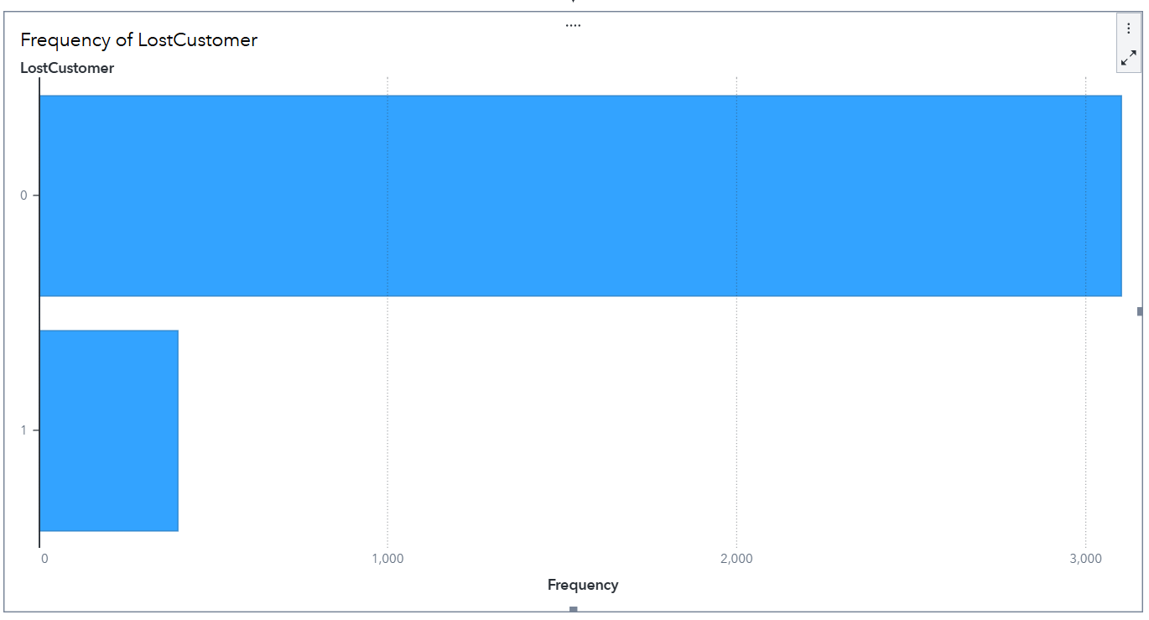
- And you can see – quickly – that while some customers churn (LostCustomer=1), we’re doing a solid job of keeping our clients at SASe. Now let’s add a few more variables on the page to further explore the data. Find customerGender. Drag-and-drop it to the right of LostCustomer, like so:
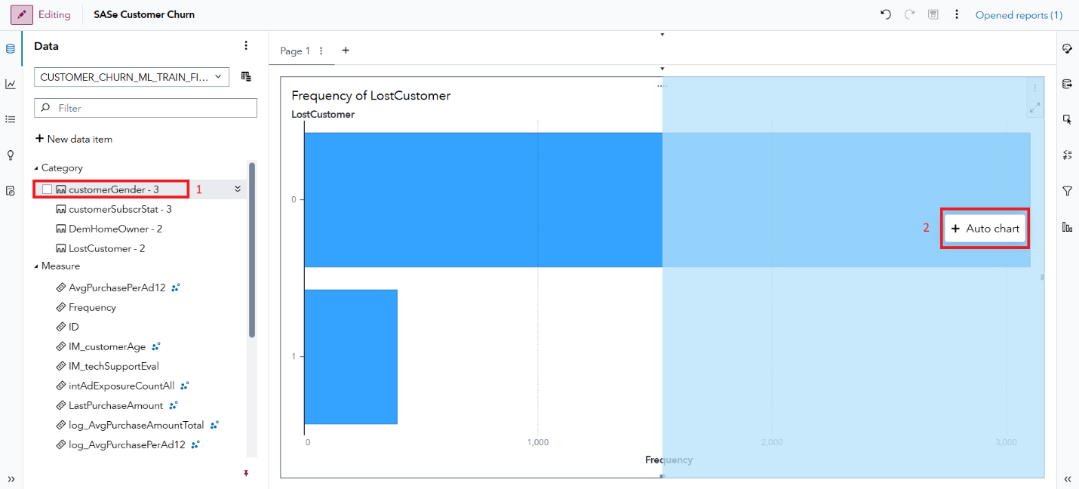
- Our dashboard is evolving!
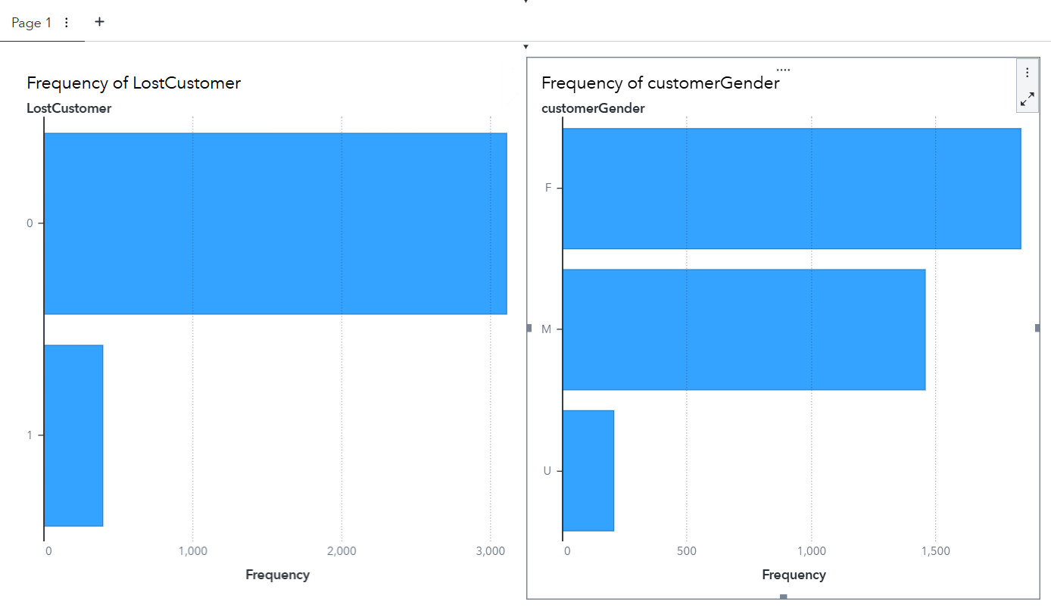
- And two notes before we add even more: (1) keep saving periodically. Like now. And, (2) drag-and-drop mistakes happen. Let the Undo button be your friend, when needed:

- Next, find customerSubscrStat and add it to the right of customerGender. Like this:
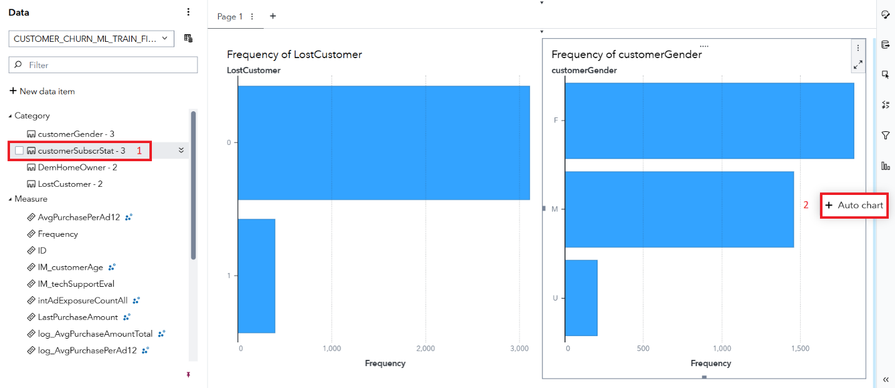
- More details are included on our page!
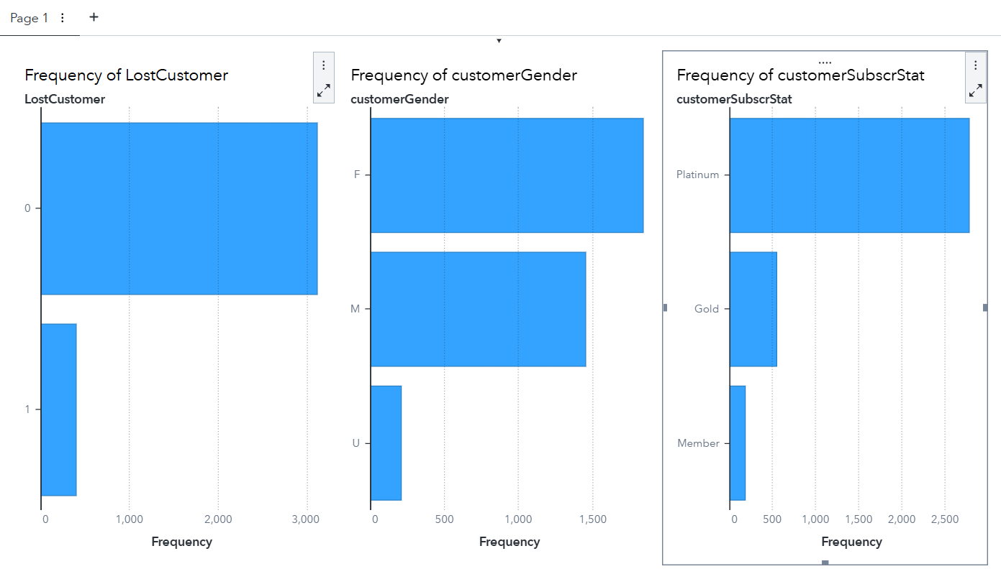
- Those are some helpful distributions on our categorical variables. Now, let’s add three Measures, just for fun. Find IM_customerAge and put it below LostCustomer, here:
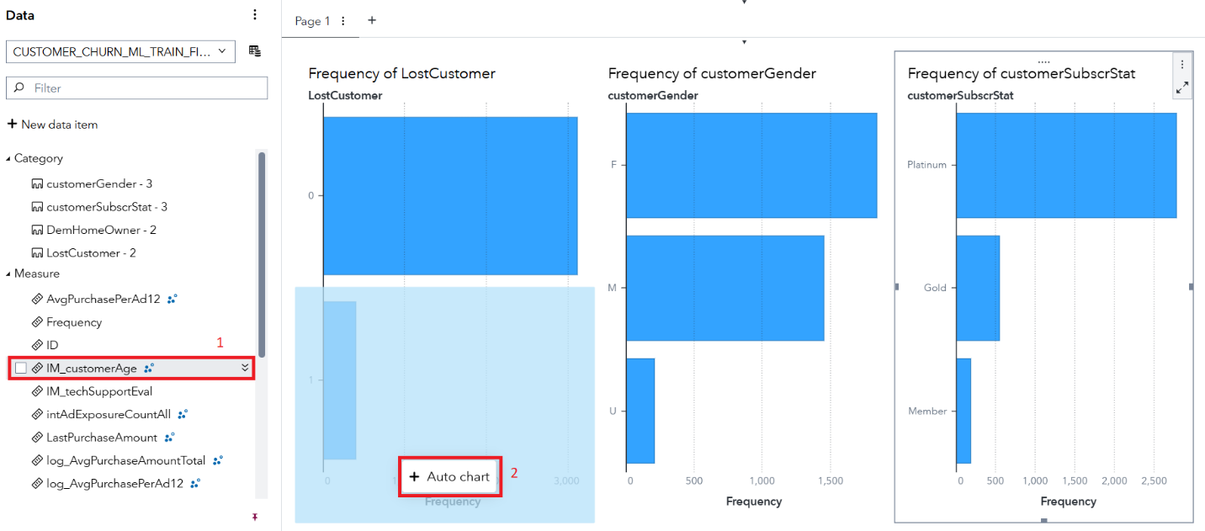
- Hmmm. Those are some strange values for age. They must be standardized somehow. Regardless, let’s also add log_customersales and wksSinceLastPurch to the bottom row. In other words, replicate the following:
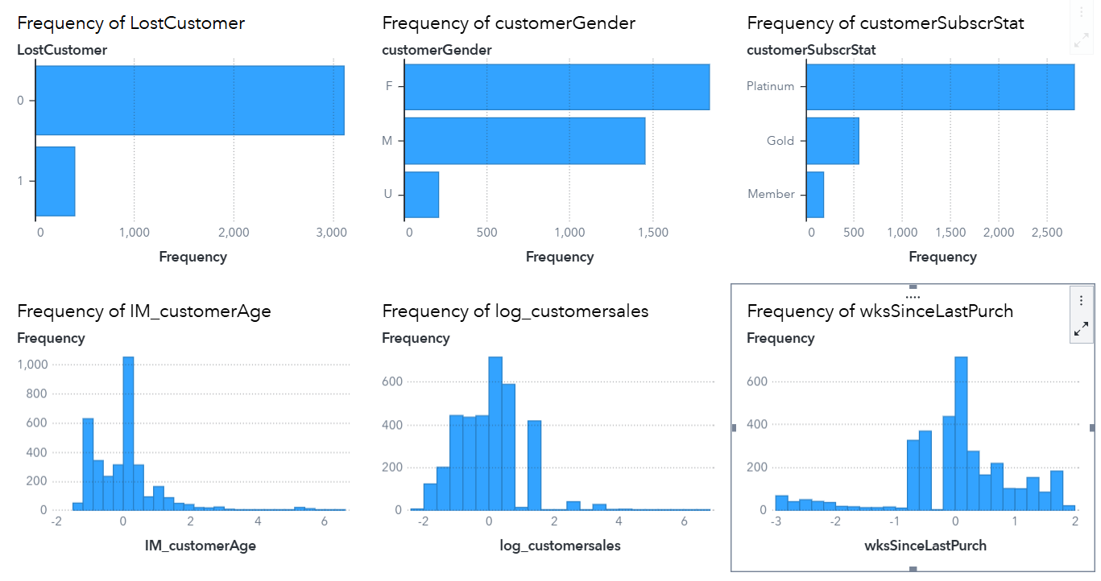
- Again, the measures appear to be standardized. But the larger point is this: with just a couple of drag-and-drops, your dashboard is off to a great start! Save to keep it around for a bit. Then find the Option menu on the page tab. Next, select Rename, like so:
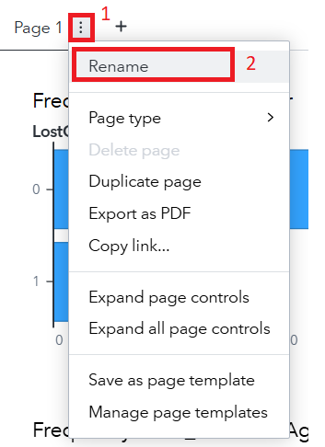
- Change Page 1 to something a bit more helpful like DescriptiveStats. Then click the New Page button, here:
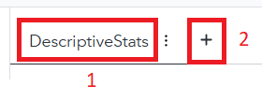
- We’ve got a new page to explore! And I’d like you to activate the Objects pane, then find Correlation matrix under Graphs. Like so:
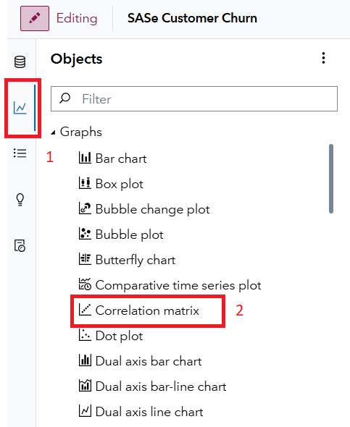
- Go ahead and drag-and-drop Correlation matrix onto your page. You’ll then be prompted to Assign data:
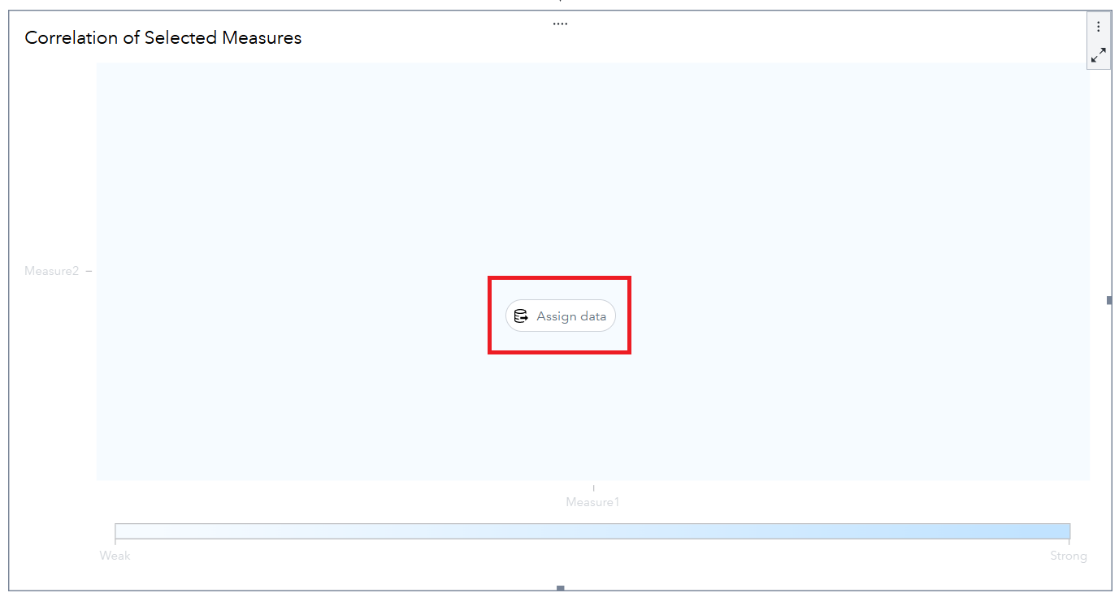
- So, let’s assign away! For Measures, click + Add:
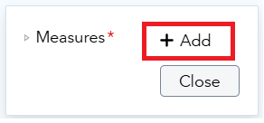
- And, just for fun, let’s see it all. Click that Select all button
- Then select Apply. You can then click Close for the pretty graph:
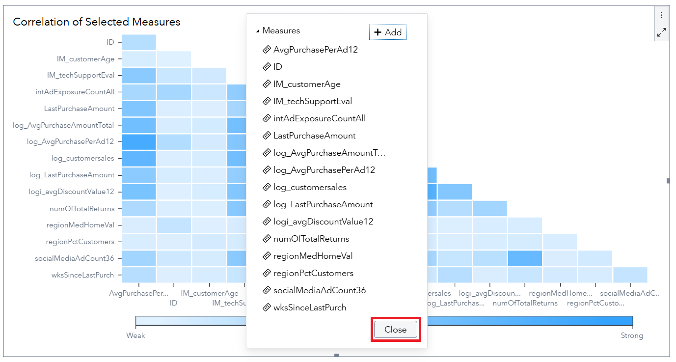
- Spend a bit of time processing correlations. To learn more about a specific relationship, you can hover above a cell to get more information. For example:
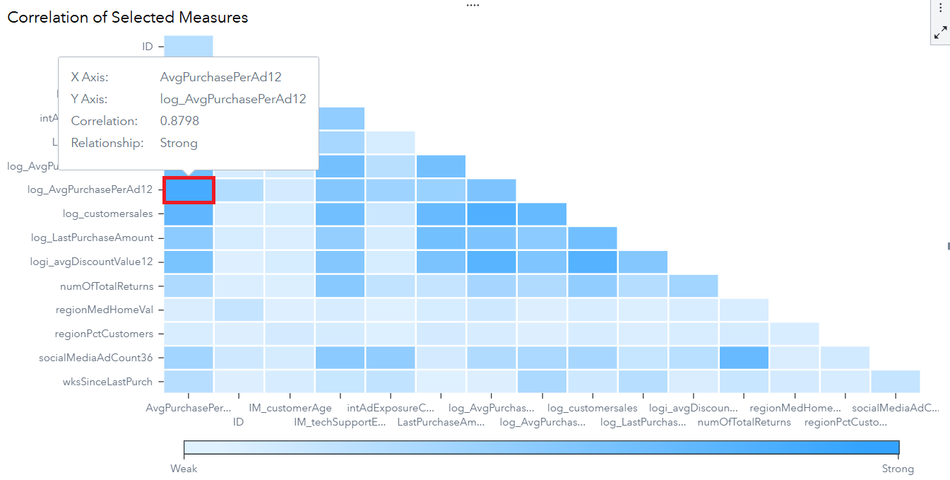
- Want individual values? Click the Maximize button in the object, here:
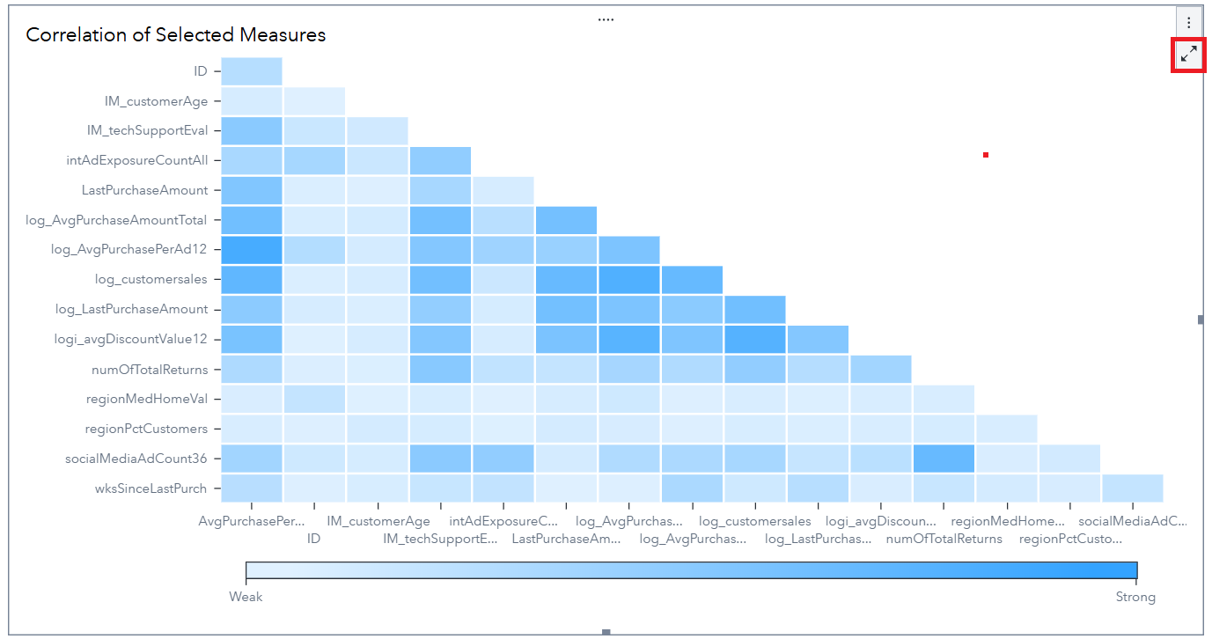
- You can now digest a whole bunch of bi-variate relationships at the bottom:
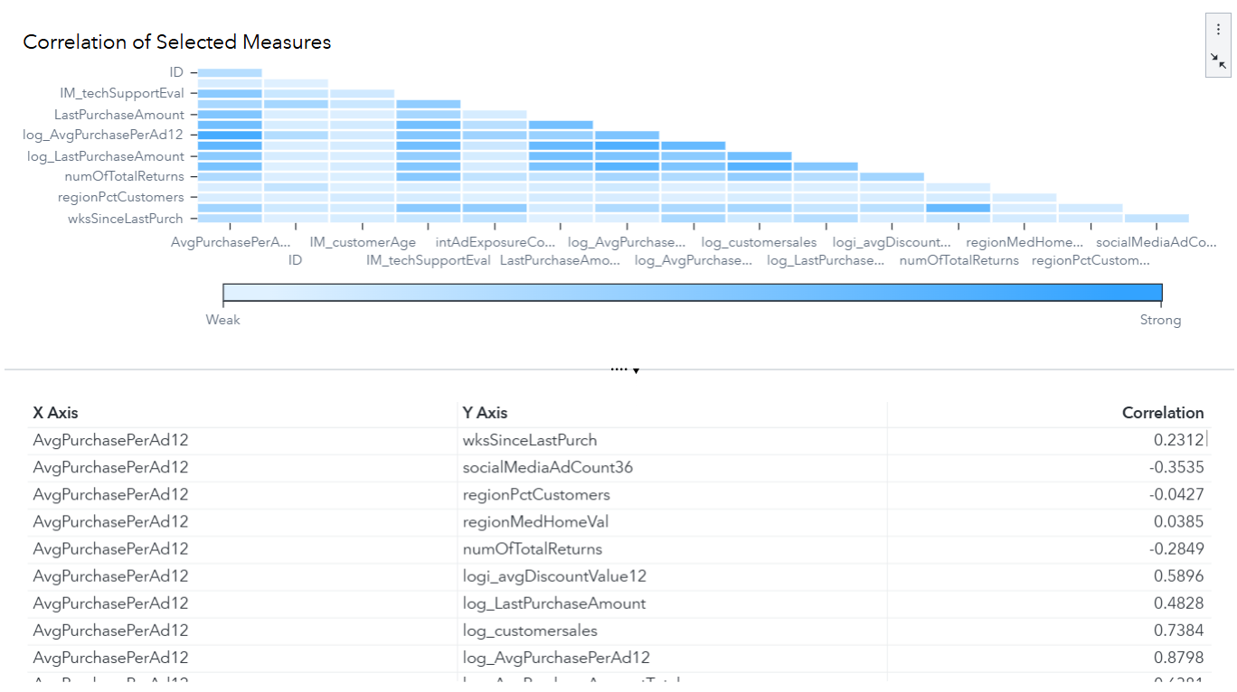
- Restore the view when you’re done by clicking here:
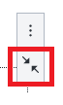
- And rename that page to “CorrelationAnalysis”. Then save. Please
- For our next trick, I’ll show you how cool the Automated Analysis object is. To start, ensure the Objects pane is active. Then scroll down to Analytics, Automated explanation. Some guideposts to get you there:
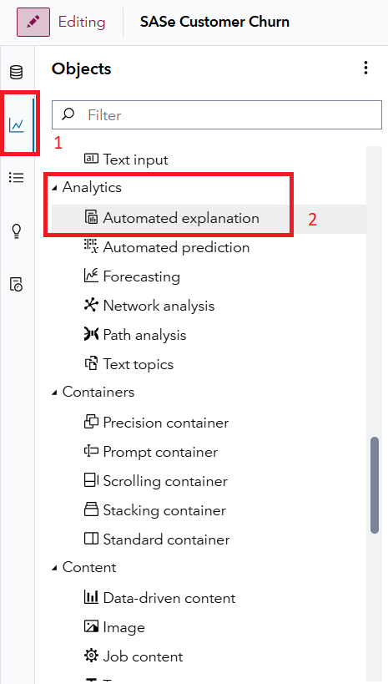
- And while you could drag and drop it onto the page, let me show you another way. Right-click on Automated explanation and then select Add to new page:
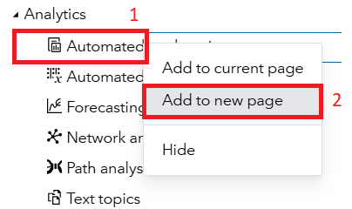
- Presto! A new view eagerly awaits. Click Assign data:
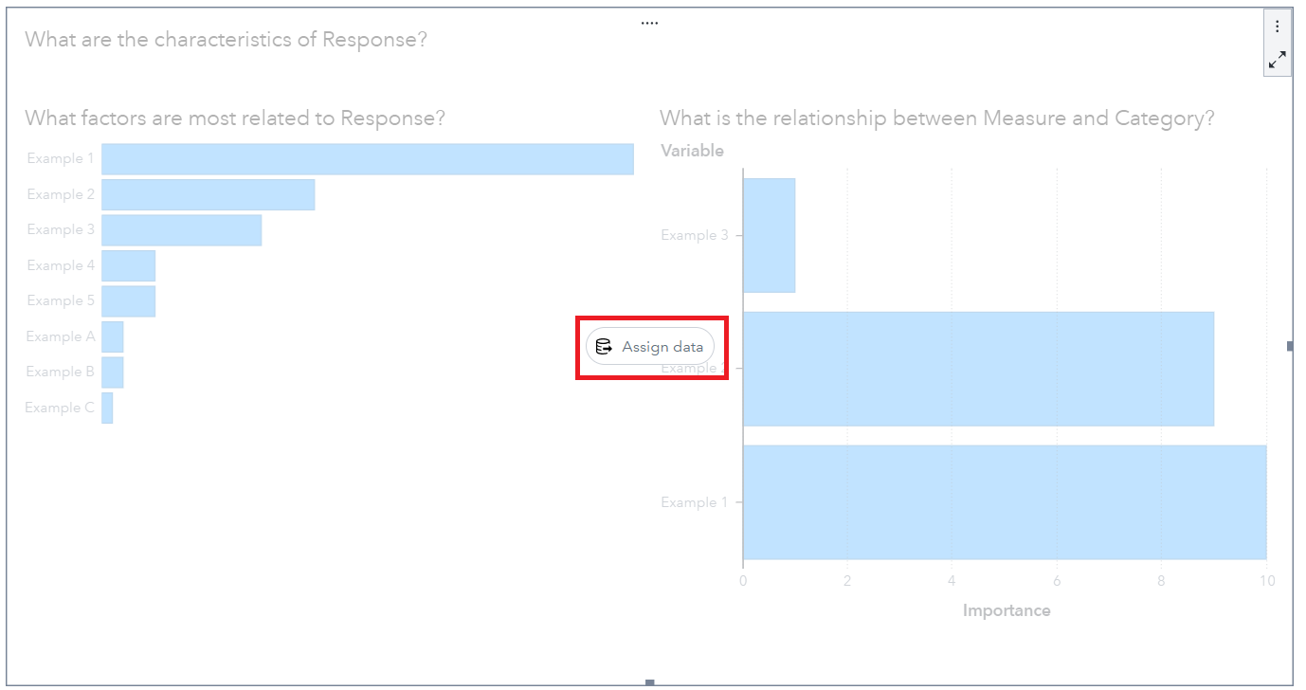
- You’ll get the following box:
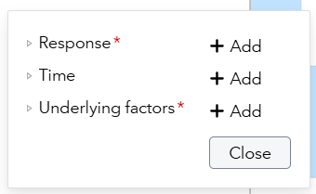
- Click + Add for Response. Then select LostCustomer. And before you can blink the following appears:
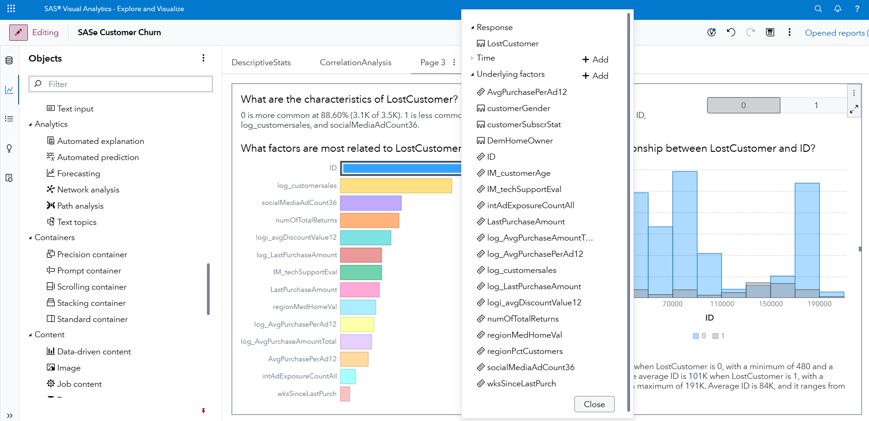
- All the response variables are included in the initial analysis. And know they’re easily modified. For example, find ID and then click the Remove icon:
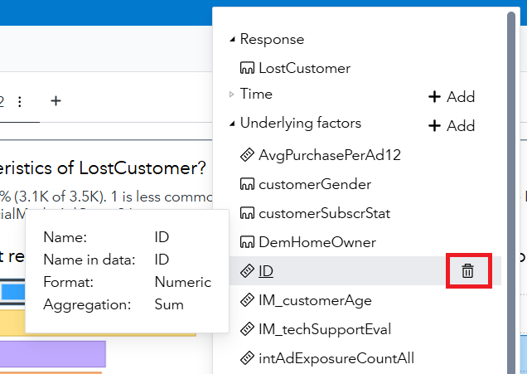
- Click Close and then we can digest some output. Actually, one more thing – select 1 as the outcome we want to analyze and then start playing with your interactive dashboard:
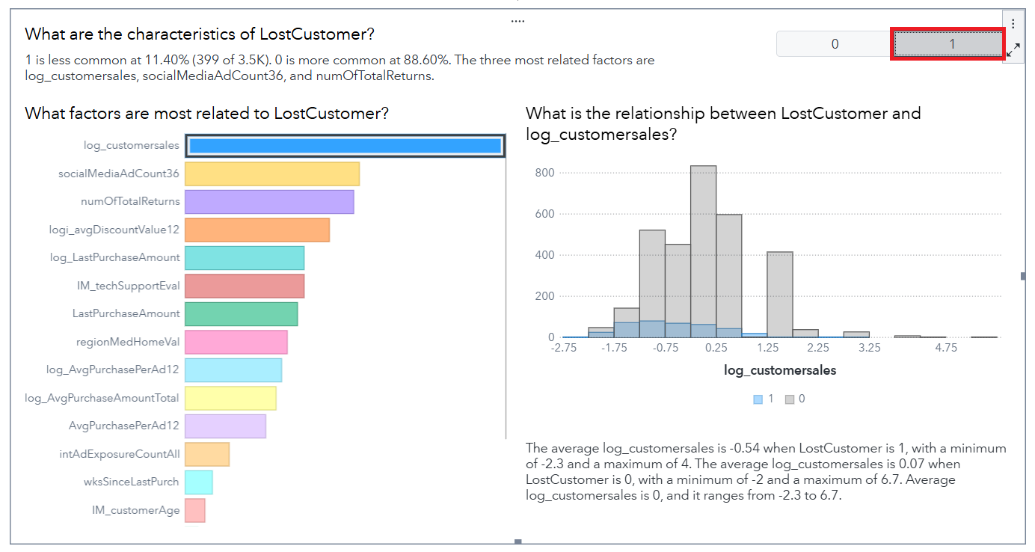
- What do you see? I find that customersales is highly related to customer churn. socialMediaAdCount and numOfTotalReturns rounds out the top 3. Additionally, when I click on IM_TechSupportEval, I see that LostCustomer is more highly correlated with a low TechSupportEval score:
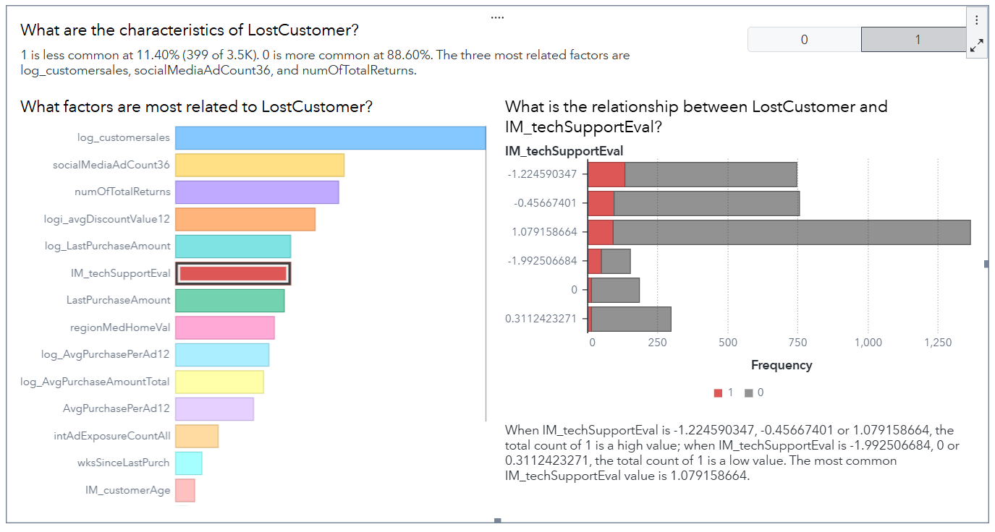
- Interesting. What do you see? Explore a bit more. Then Save. And we can also change the name of the page to AutomatedAnalysis, like so:
- Three pages down in our dashboard. Woot! While we have other tools for modeling, let’s show you how easily we can incorporate SAS Visual Statistics into our dashboard. Find the Options button for the AutomatedAnalysis page. Like here:

- Now select Duplicate page:
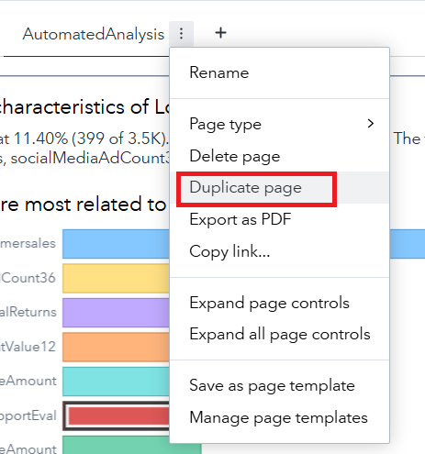
- What have we done? Well, we carried through the existing metadata to a new page. (What is metadata? Well… data about data. So meta!) With just a couple of clicks, we can then change the existing object into a model. Start by clicking the Object Menu for Automated explanation. Then select Change Automated explanation to > Decision tree. Like so:
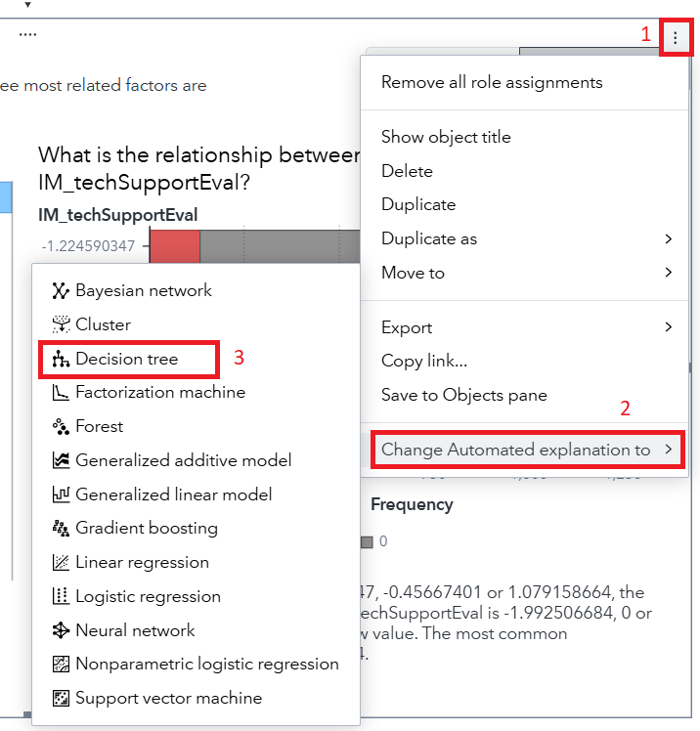
- And, instantly, a decision tree is created!
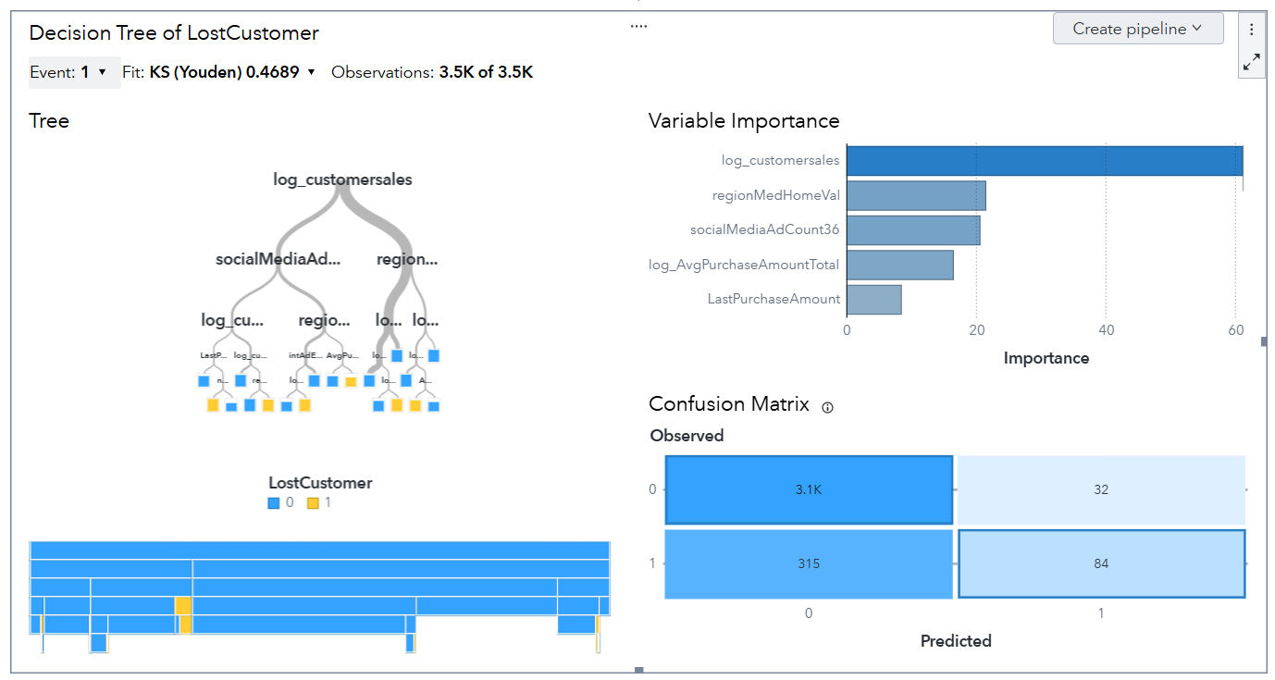
- Like our Automated explanation object, this one is interactive, too! So, spend a bit of time playing with the interface. For example, you can zoom into the decision tree to learn more about the breakpoints:
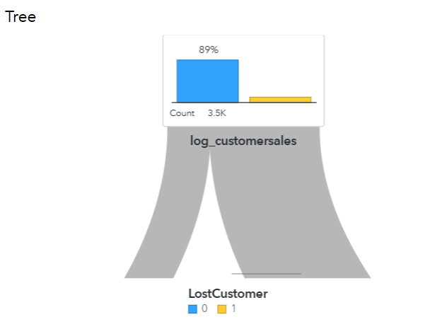
- After exploring, please Save. And then rename the page to DecisionTree. And, in just a couple of minutes, you’re several pages into your dashboard:
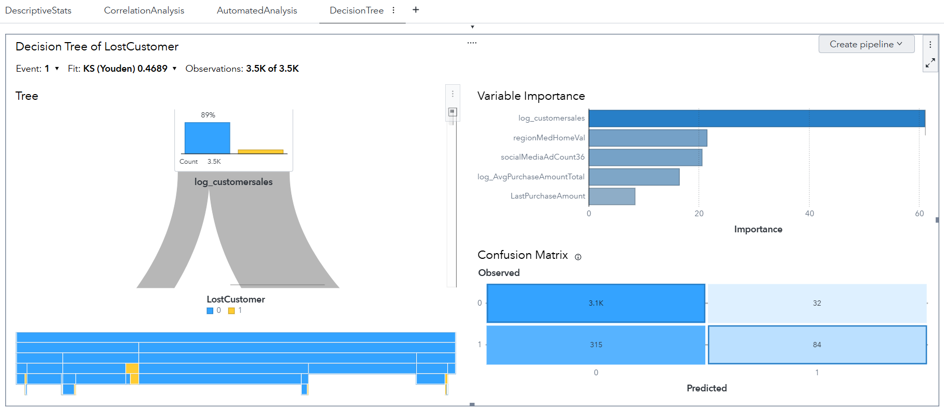
- While we can do a LOT more in SAS Visual Analytics, we’ll stop here in the interest of time. Why, because SAS Model Studio is a WAY more powerful modeling tool than SAS Visual Analytics, and I want to get you into that environment, ASAP. Find the Create pipeline button and then select Add to new project. Like so:
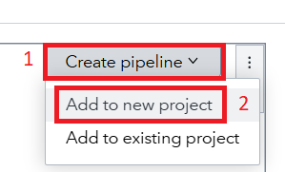
- Your project will be transferred over to SAS Model Studio… and I’ll see you there!

Modeling in SAS Model Studio
Ready for the wonderful world of SAS Model Studio? If you’re just getting started with predictive modeling and machine learning – or a veteran who is simply tired of all that coding – then SAS Model Studio is the place for you! Let’s get right back to where we left off in our analysis of LostCustomers in the SASe Customer Churn project!
- If everything transferred properly from the Decision Tree in your SAS Visual Analytics report, you should land in the Pipelines tab in SAS Model Studio:
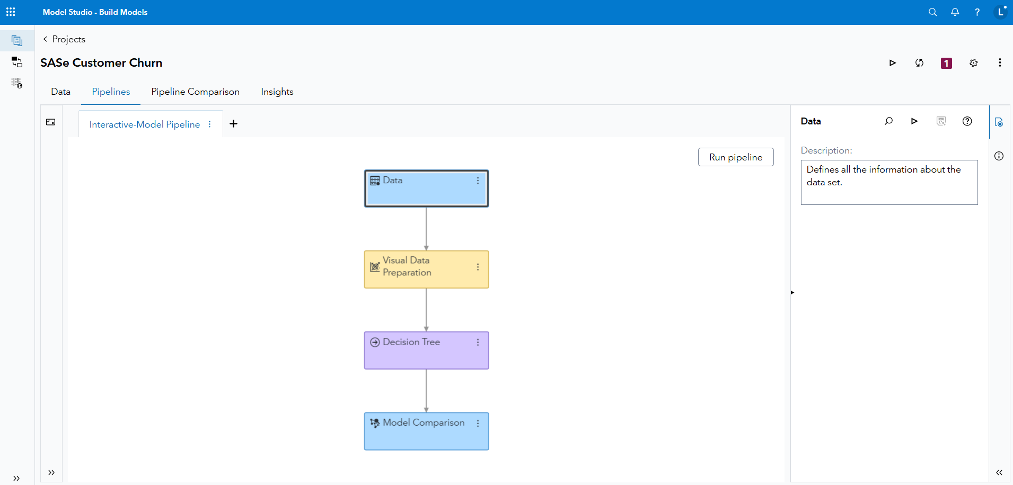
- Pipelines are analytical process flows that take us from data discovery and cleaning to modeling. SAS Model Studio is node-driven, and you can see all the options available to you by clicking on the Nodes tab. For example, I’ll expand the Data Mining Preprocessing tab just to show you some of the options available:
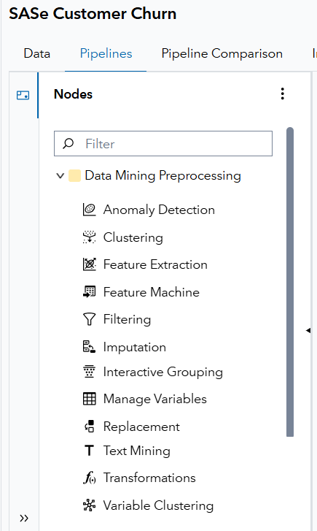
- Yup… that’s a lot to explore! But we’re a bit pressed for time, so I’ll have you just do one thing to this pipeline. Right-click on the Data node. Then select Add child node >> Miscellaneous >> Data Exploration. Like so:
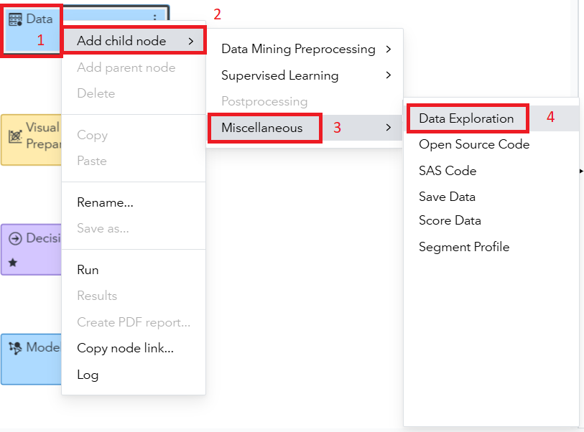
- Your pipeline should appear as:
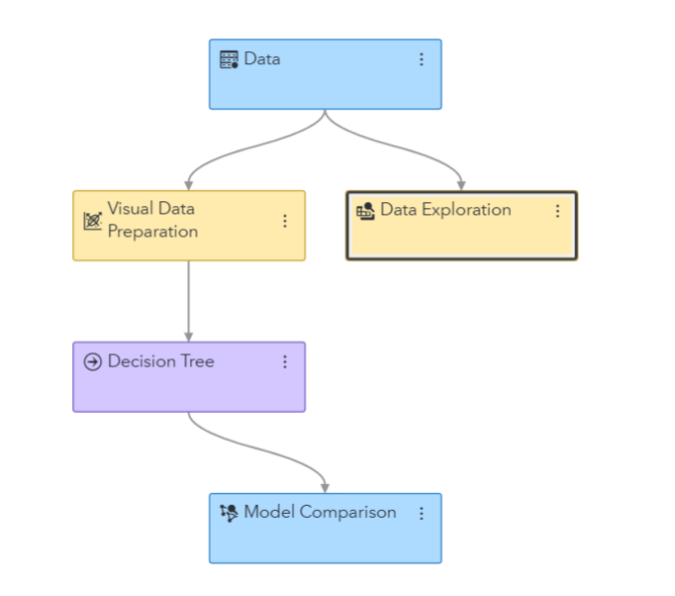
- Then just find and click that Run pipeline button:

- While that pipeline is running, let’s see if we can beat our model from SAS Visual Analytics with one of our pre-built pipelines in SAS Model Studio. Find and click the Add new pipeline button:
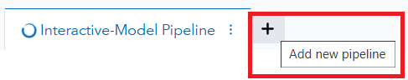
- A New Pipeline window appears:
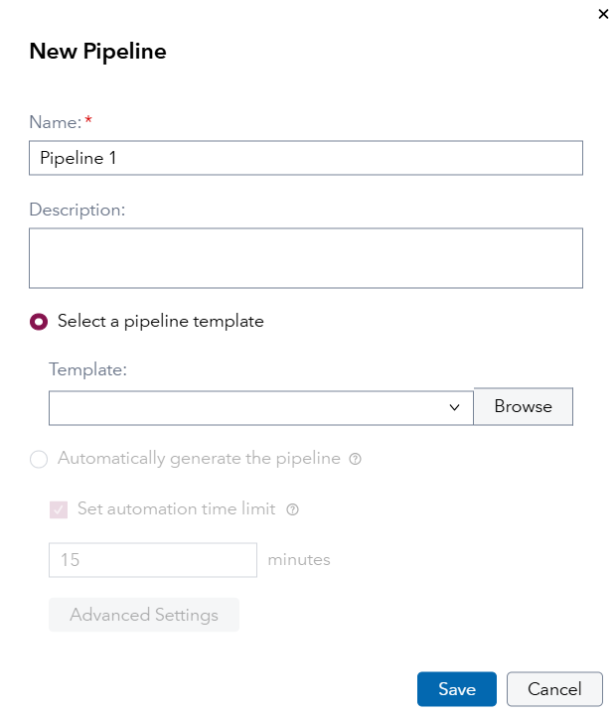
- Let’s make a couple of updates to those settings. For Name, type Advanced Pipeline. Then click the Browse button under Select a pipeline template. In VFL there may be a LOT of other templates out there. But ignore them and simply find the one that says Advanced template for class target, with the Owner of SAS Pipeline… i.e., this one:
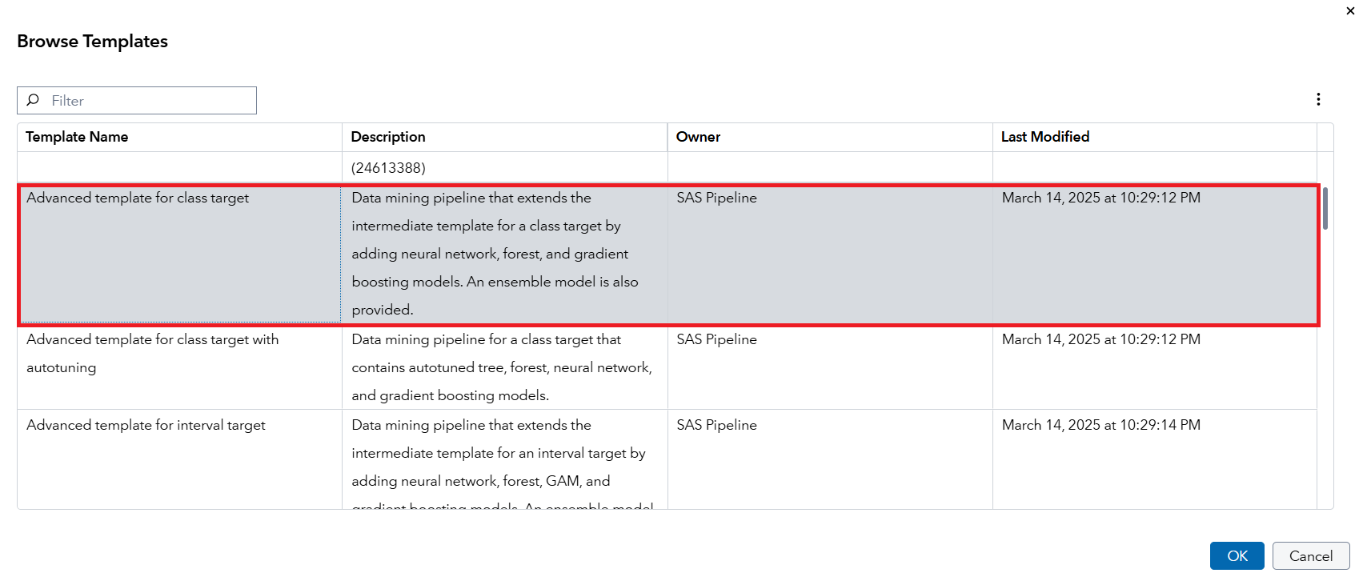
- Click OK… which then takes you back to the New Pipeline window. With the following cumulative settings:
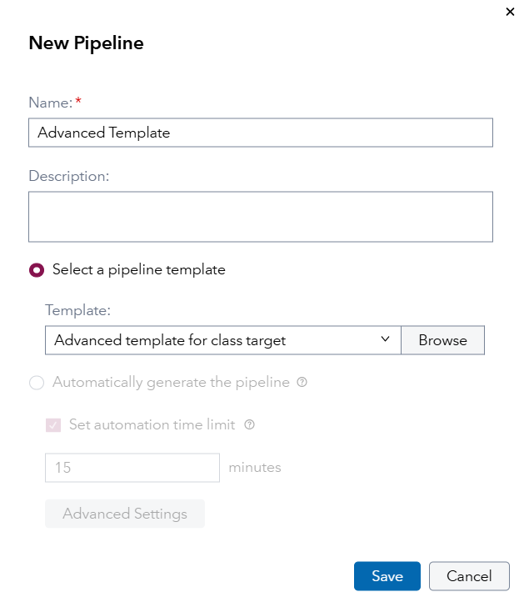
- Click Save and be prepared to be impressed by your new pipeline:
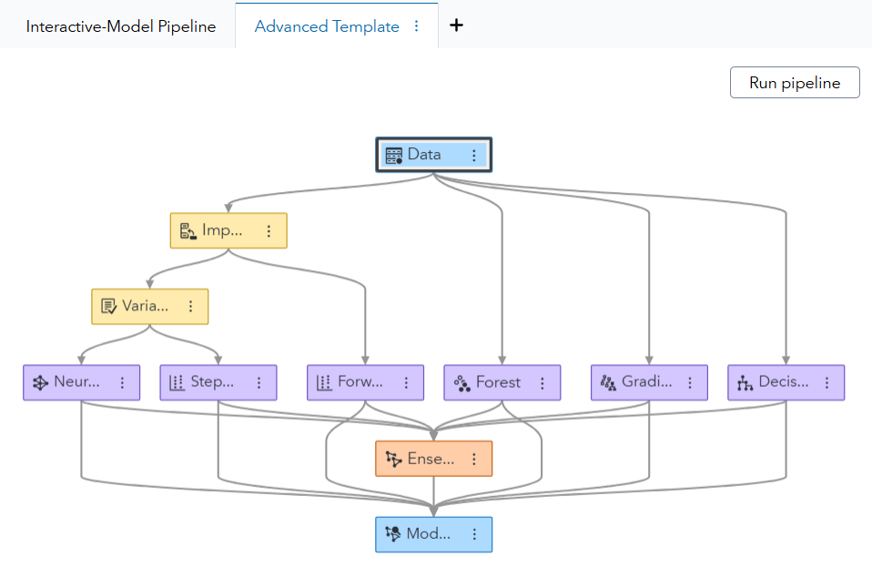
- Do you see what I see? 7 advanced predictive models… for the price of just a couple of clicks. One more gets the pipeline to run:

- Run it! And while it’s doing a TON of data preprocessing and then modeling, let’s slide over into our coding adventure. Don’t worry, we’ll return to SAS Model Studio to digest the results!

SAS Studio in SAS Viya (Steps and Flows)
SAS Studio provides a robust environment for programmers to access and develop code. In this demonstration, you learn how to navigate the interface to write and submit SAS code, as well as use helpful programming features.
- Open SAS Studio from the applications menu by selecting Develop Code and Flows.
- The navigation pane on the left provides access to our SAS resources, including data, programs, and other items. The workspace area contains multiple tabs that enable you to build programs and flows. From the Start page, select Program in SAS. Or select New > SAS Program.
- Enter the following program in the editor. This program creates a new table named CLASS_NEW, reads SASHELP.CLASS, computes a new column named Ratio, and prints the result.
data class_new;
set sashelp.class;
Ratio=height/weight;
run;

proc print data=class_new;
run;

- Click Run. Additional tabs are available to view the log, results, and output data. Select (More Options menu) and select Apply detail layout to choose other tab arrangements. Select Standard to view one tab at a time.
Note: To change the default tab layout, select your SAS Profile icon in the upper-right corner, then select Settings > Code and Log > Detail tab layout.

- If you have experience with SAS code, notice there is nothing new or different about the syntax. Most code that was developed for a previous version of SAS will run on the SAS Viya platform on the SAS Compute Server.

- Existing SAS programs and other files can be saved and accessed in either SAS Server or SAS Content.
The SAS Server pane provides a direct view of the server's file system, which is where your SAS programming session is running. You can view, upload, and download files in your home directory or other areas you have permission to access. For example, if you want to upload data to process in a SAS program, it is best to load it to a location under SAS Server. Select a folder in SAS Server, then click (Upload) and select one or more files from your local machine.
The SAS Content pane is the content storage area used by SAS applications (like SAS Visual Analytics, Model Studio, Intelligent Decisioning, etc.) to organize and access shared resources. SAS Content is typically used to store SAS-specific assets, such as reports, models, or jobs.
- Select the Snippets pane. Snippets enable you to store and insert template code into your programs. SAS provides a collection of predefined snippets, or you can create personalized snippets. Under SAS Snippets, expand Viya Foundation > Cloud Analytic Services and double-click Generate SAS librefs for caslibs. The snippet opens in a new tab.

- You can also insert a snippet in an existing program. On the SAS Program.sas tab, insert a blank line after the last line of code. Then drag Generate SAS librefs for caslibs from the Snippets pane into the editor. The snippet is inserted where the cursor was in the program.
Note: The code in this snippet will be used later because it defines SAS library references for each of our caslibs, which is where our in-memory data is stored.

- Next, select the Library Connections icon, which provides access to your defined data sources. SAS libraries defined in the environment are listed. Highlight the snippet code inserted into the program and click Run. Additional cloud icons are now displayed in the Library Connections pane, providing access to defined caslibs for in-memory data.

- Expand the WORK library and double-click CLASS_NEW to open the interactive table viewer. Right-click the Age column and several options are available to view, sort, or filter. Select Sort > Ascending.
Many other options are available to filter the data. Type Age > 13 in the Expression field and press Enter. You can also click (Filter) to use the Expression Builder window. Change 13 to 12 in the expression and click Save. All previous filters can be easily accessed by selecting (Saved filters). Close the WORK.CLASS_NEW tab.

- Another convenient shortcut in the Library Connections pane is the ability to select a table name or columns and insert them into a program. On the SAS Program.sas tab, add a VAR statement in the PROC PRINT step. Rather than typing multiple column names, expand CLASS_NEW in the Library Connections pane. Hold down the Ctrl key and select Name, Age, and Ratio and then drag them into the program. Complete the statement with a semicolon.
proc print data=class_new;
var 'Name'n Age Ratio;
run;

Now let’s look at Steps and Flows within SAS Studio:
- Return to the Start Page on SAS Studio.

- Click on Build a Flow.

- We must first place a data set on the flow that we wish to process. Click on the Library connections icon and expand the WORK library.

- Click and drag the CLASS_NEW data set to the Flow area.

- Click on Steps icon. SAS R&D has provided many premade steps that you can use within your analysis. You also have the option to make your own custom steps. Expand the Statistics folder and scroll down to locate the Distribution Analysis step. Click and drag this step to the Flow area.

- Click in the empty flow space so that neither the data set nor the step are highlighted. Point at the data set along its edge where the cursor turns into a hand. Click and drag from the data set to the step. An arrow will appear connecting the two. This tells the step to use this data set in the analysis.

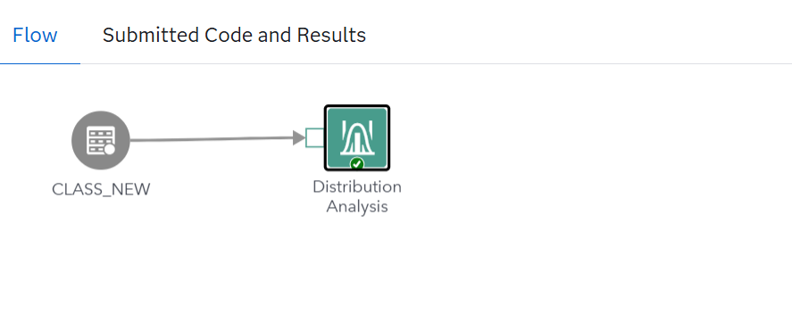

- Click the Distribution analysis step. While highlighted, the bottom area of the flow displays the options for the selected step.

- With the Data tab selected, click the + icon for Analysis variables. Click the check boxes next to Age and Weight. Click OK.

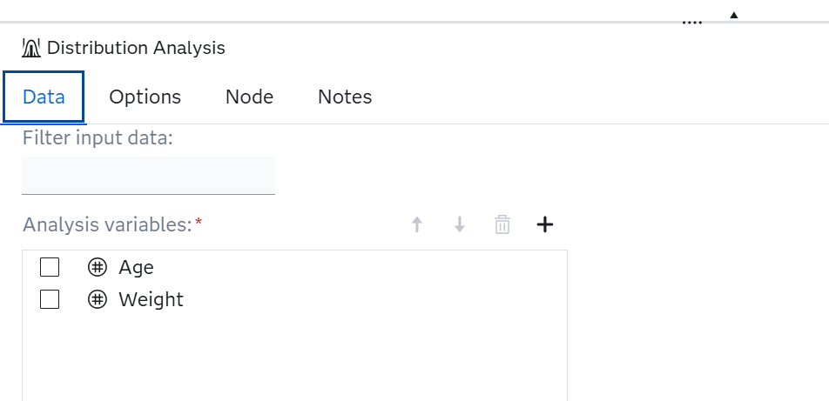

- With the Options tab selected, click the check boxes next to Add normal curve, Add kernel density estimate, and Add inset statistics. Expand the Inset Statistics dropdown. Remove the check mark from Number of observations. Check the boxes next to Mean, Median, and Standard deviation.

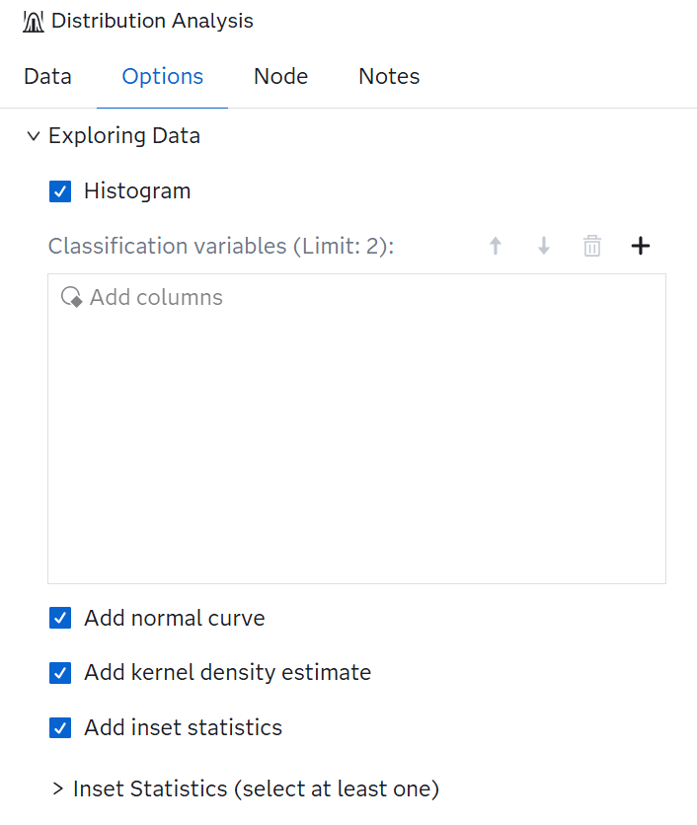

- Under Checking for Normality, check the boxes next to Histogram and goodness-of-fit tests, Normal probability plot, and Normal quantile-quantile plot.

- Click Run to run the flow. Select the Submitted Code and Results tab to see the output.

Sampling of the output provided:
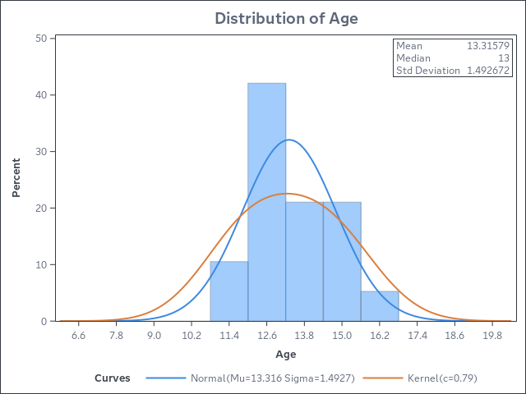

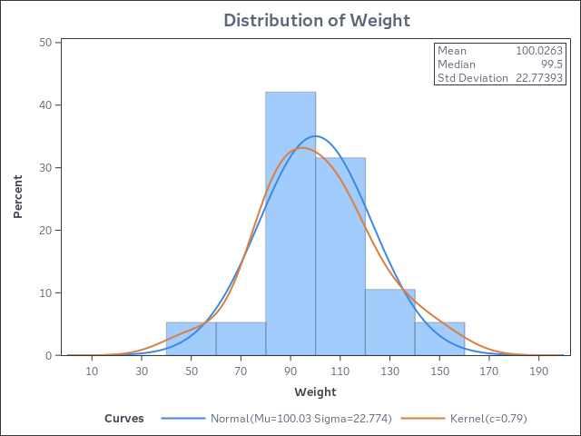

Copilots within SAS Viya
SAS Viya Copilot transforms natural language into analytical actions, recommendations and explanations.
- When Copilot is enabled, you will see the icon below on the ribbon to the right of the Applications menu.
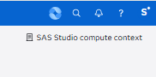
- SAS Copilot provides controlled AI execution with human oversight and enables faster data and AI development to increase productivity.

- SAS Copilot can be useful in a step in an analytic workflow. We’ll run the following prompts in a Model Studio project to illustrate this.

- Return to SAS Model Studio. Add a new pipeline. Name it Copilot Testing and leave it with the blank template. Click Save. Click the Copilot icon in the upper right. Copy and paste the following prompt.

“Add a Data Exploration node to summarize key data quality metrics, including missing value percentages, variable data types and potential outliers across all interval and nominal variables.”

“Add an Imputation node to the Model Studio pipeline to handle missing values. Use median imputation on interval variables and mode imputation on nominal variables”.

- SAS Copilot can also create a complete analysis. Submitting the following prompt in a Model Studio project creates a fully built-out pipeline.

“Create a SAS Viya Model Studio pipeline for a binary target variable. Add an Imputation node to handle missing values and add a Variable Selection node. Add a Replacement node. Add the following modeling nodes; logistic regression, decision tree and gradient boosting”
SAS Viya Copilot can benefit data scientists, analysts, developers and executives by providing on-demand insights, accelerating modeling and streamlining code and documentation.

Using Open Source in SAS Viya (Jupyter Notebook)
JupyterLab in SAS Viya for Learners provides a way to access Viya functionality in a way that may be more familiar to open-source users.
To access JupyterLab, go to the Viya for Learners landing page.

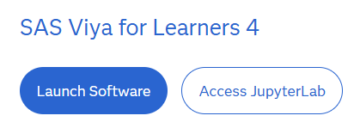
- Once JupyterLab opens, navigate to /data/courses/POSI/, then double click the Python_Machine_Learning_Demo notebook.

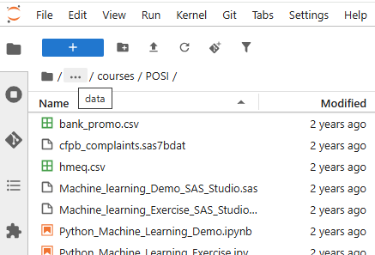

- This notebook implements an end-to-end machine learning analysis.
  - Part 1 reads the data into memory and then assesses, repairs and modifies the data to prepare it for modeling.
  - Part 2 trains machine learning algorithms and then selects a champion based on honest assessment.

Your instructors will provide an overview of the syntax and then you will be ready to explore the notebook on your own.

Loading your own data and notebooks to JupyterLab
- We’ll start by creating a new folder to receive your files. This step is optional. Navigate to the home or root folder and then select the New Folder button. Name your new folder.

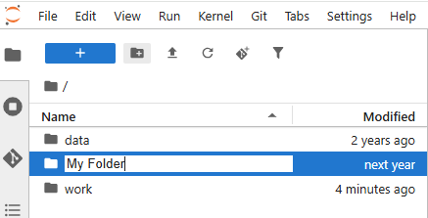

- To upload your own data and notebooks, select the Upload Files button.

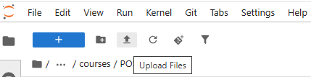

- Navigate to the directory on your local machine that contains the files you want to upload. Select the files and click Open. Note, you can ‘Ctrl-click’ to upload more than one file at a time.
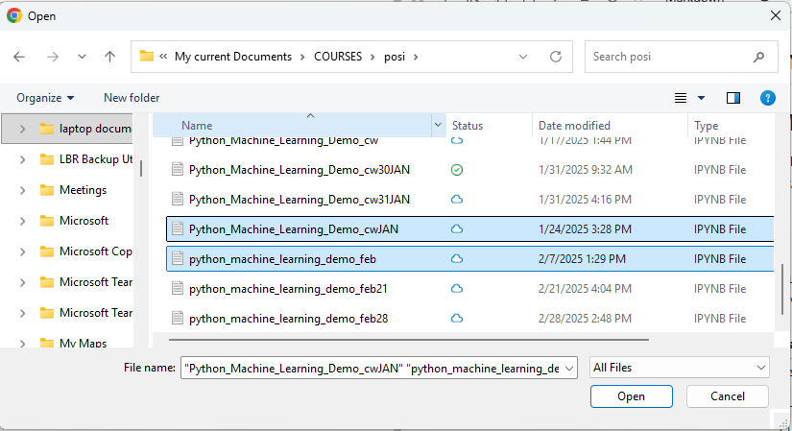

SAS Viya Workbench – Bonus Information
Where my coders at?
And by coders, I mean SAS, Python, and/or R coders!
Well, this next part of our SASe data exploration is just for you! And it’s going to require us to slide into another software offering from SAS: SAS Viya Workbench for Learners (WFL). What is SAS Viya Workbench? Well, it’s a lightweight, coder focused environment that provides easy access to SAS, Python, and R code… accessed via either Visual Studio or Jupyter.
In this section, I’ll show you how to access similar code – in both SAS and Python – code that’s being automatically generated in SAS Model Studio with just the click of a few buttons. Why? Well, because there is still a HUGE market for coders out there, as coding unlocks the full potential of any coding language. And SAS Viya Workbench will help you do that seamlessly. Plus, I may be able to get some of you interested in taking the Modern Data Science with SAS® Viya® Workbench and Python course, which is nearly 4 riveting hours of content!
But… don’t let me get ahead of myself. It’s time to get into SAS Viya Workbench for Learners. Let’s go!
- For the uninitiated, a SAS Viya Workbench for Learners adventure begins here: www.sas.com/workbenchforlearners
- Once you have a SAS profile and accept the terms of use, you should be taken to the SAS Viya Workbench for Learners product page: Course: SAS Viya Workbench for Learners. It looks like this:
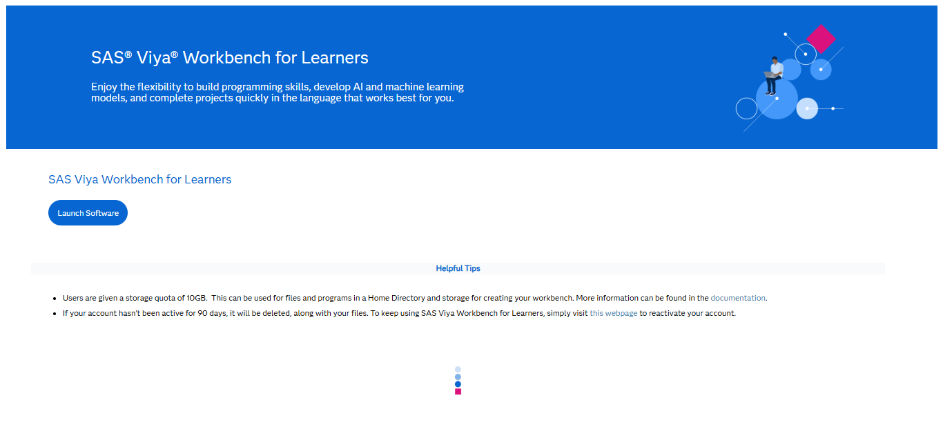
- Click the Launch Software button above to get started!
- If this is your first time in SAS Viya Workbench, you’ll need to create a New workbench. And creation is just a few button-clicks away:
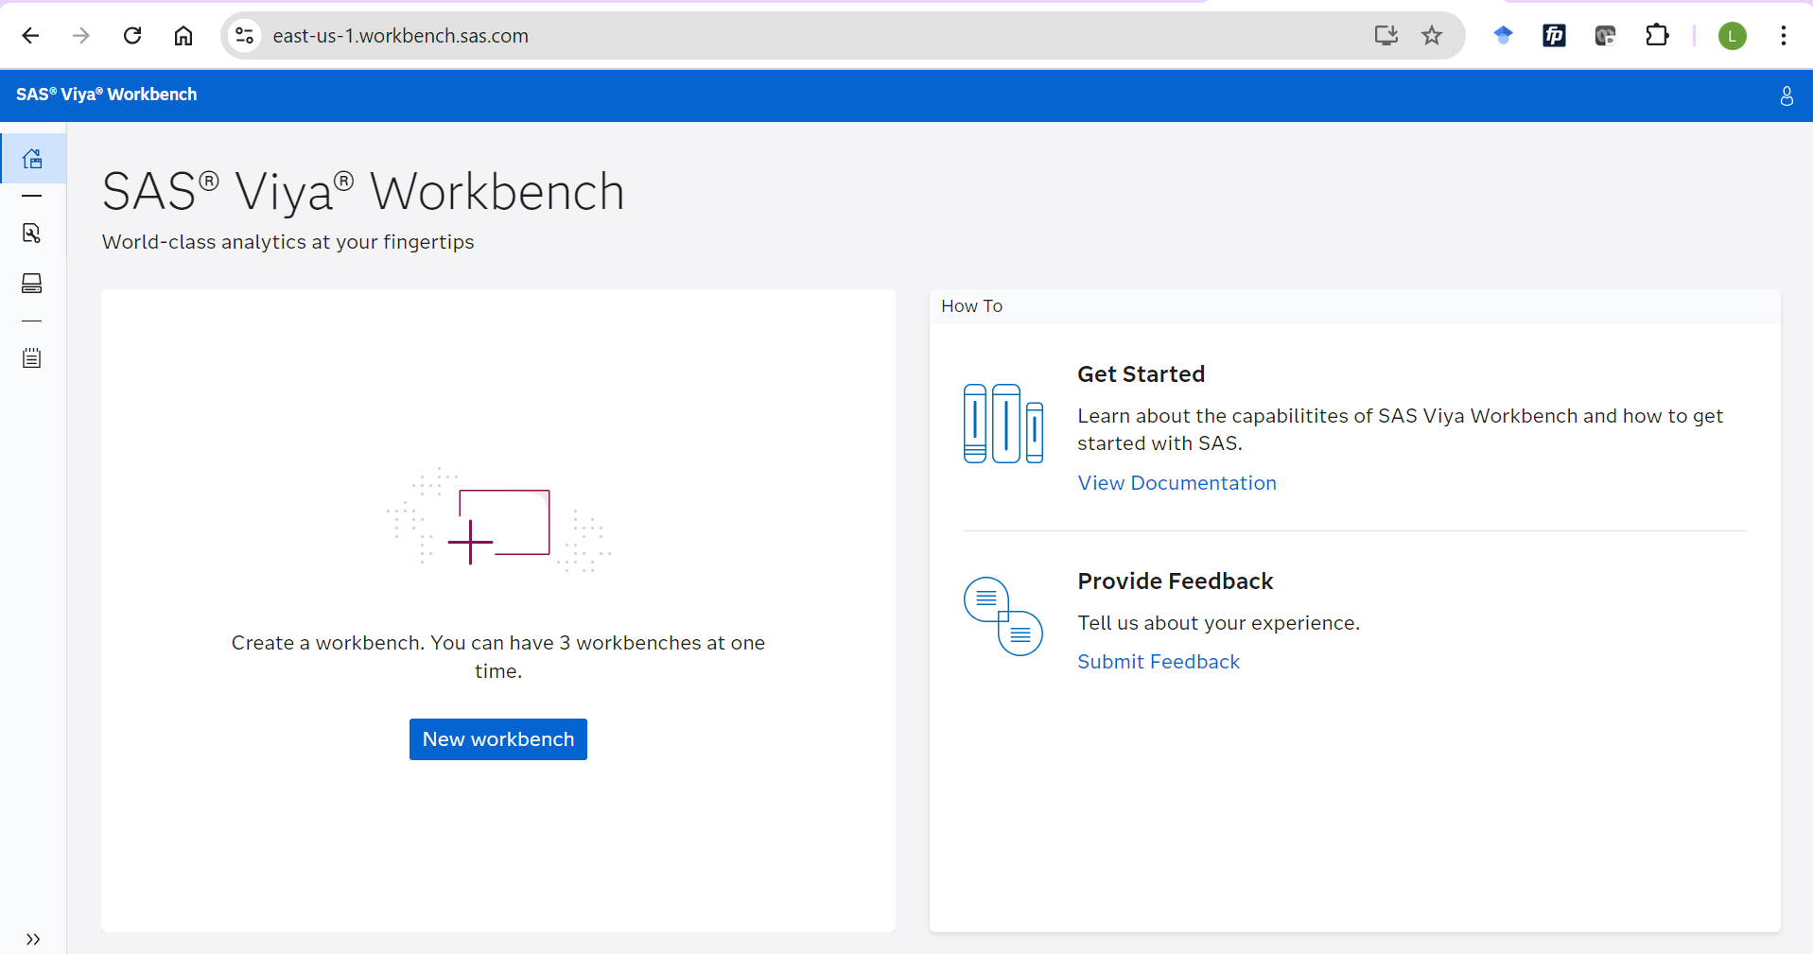
- But before getting right to it, spend a little time getting acquainted with the WFL landing page. For example, check out the Get Started resources, or those Workbenches and Storage icons on the left side. In other words, just become more and more comfortable with the resources available on the WFL landing page. And when you’re satiated, click that New workbench button:

- The following dialog box should appear:
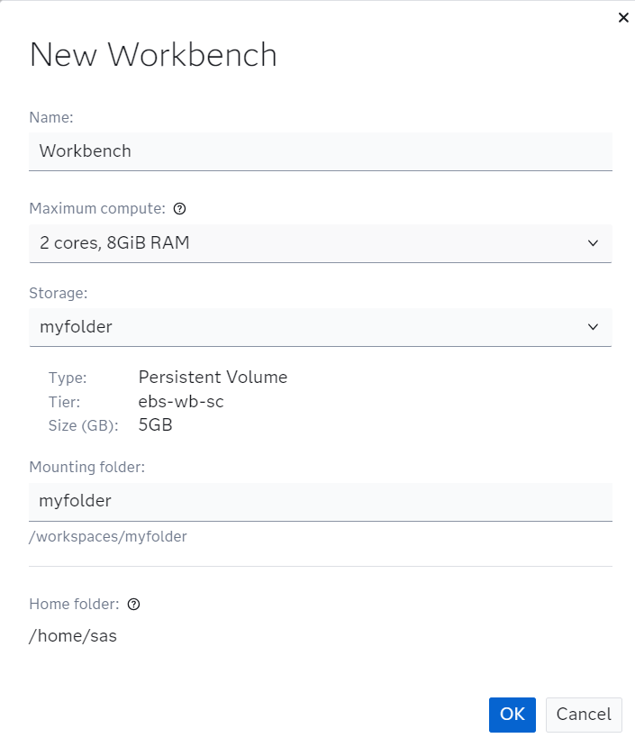
- For Name, let’s just keep Workbench to simplify. And, in fact, just keep the other settings at their default and then click OK. Success looks like this:
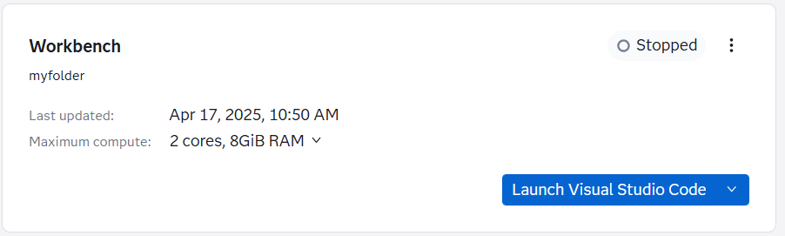
- Next, in our new workbench, click the Launch Visual Studio Code button, here:

- Your workbench container loads! And welcome to Visual Studio!
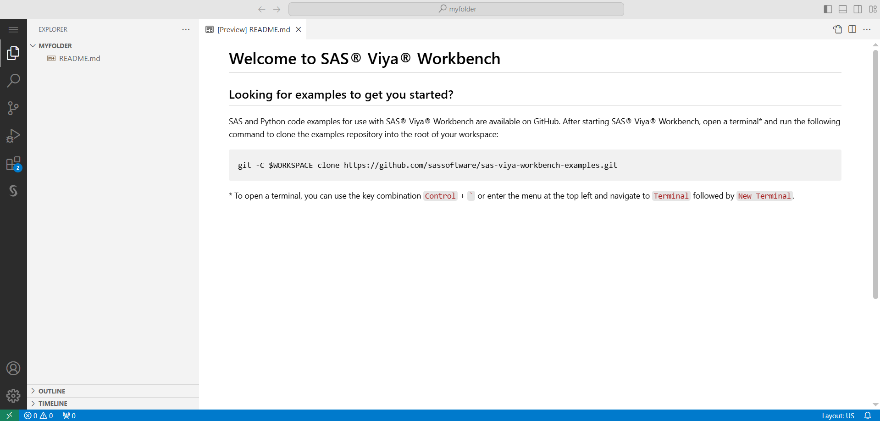
- If this is your first time in the environment, explore the Visual Studio environment for a bit. Because we’re all about exploring and learning here.
- Once you’re more comfortable with Visual Studio, the final setup task is to access the data for this SAS Guided Demo. You’ll want to access the Terminal – which is likely hidden by default. No worries – it can be activated via the Toggle Panel if it’s not already available. And that button is in the upper-right corner, here:

- And a happy terminal will look like the following:
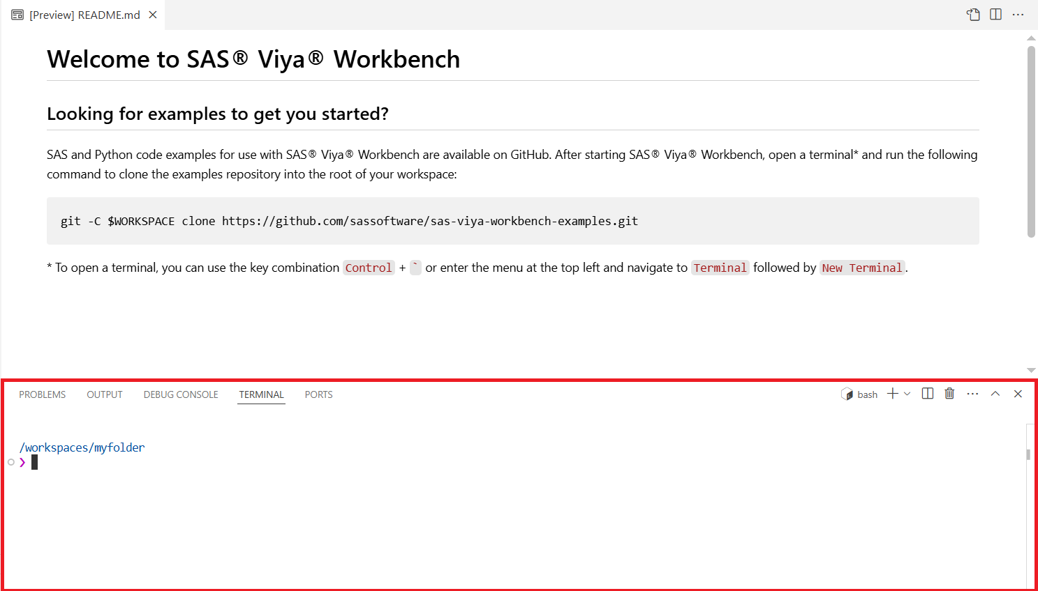
- You’re almost there! Simply type the following line of code into the Terminal:
git clone https://github.com/sassoftware/sas-education.git
- Then hit Enter. Success looks like this:
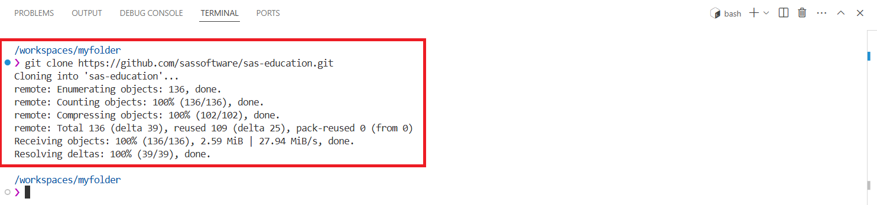
- The files that we’ll need for our day 1 adventures at SASe can be found in the Explorer. The files are a couple of layers down into the folder, so follow this path: MYFOLDER >> sas-education >> sas1. And here are some click checkpoints to guide you:
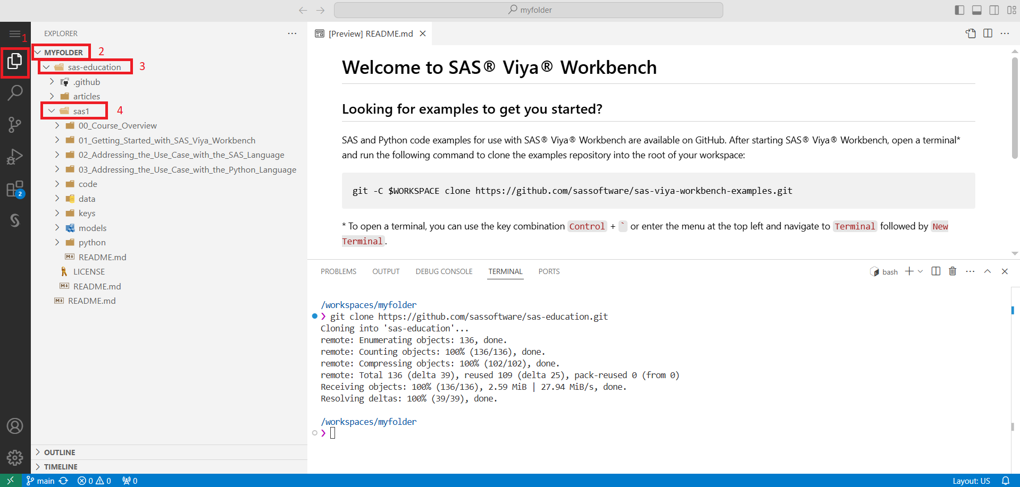
- Files are a great thing to have. And, believe it or not, you are mere clicks away from the awesomeness that is running SAS and Python code in Visual Studio. Without further ado, let’s get at it… one by one!

Modeling in SAS
- Open the 02_Addressing_the_Use_Case_with_the_SAS_Language folder under the sas1 folder in SAS Viya Workbench. Then find – and expand – the 02_03_Machine_Learning folder. Three notebooks await!
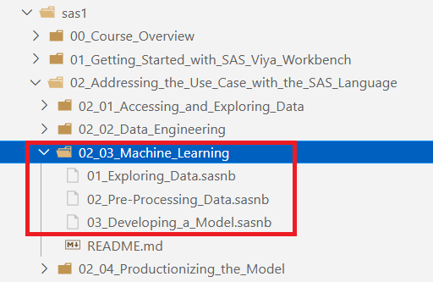
- And, yes, those numbers denote the order you’ll run them in. So, start with 01_Exploring_Data.sasnb… as in double-click it. You’ll see your very first SAS Notebook in Visual Studio:
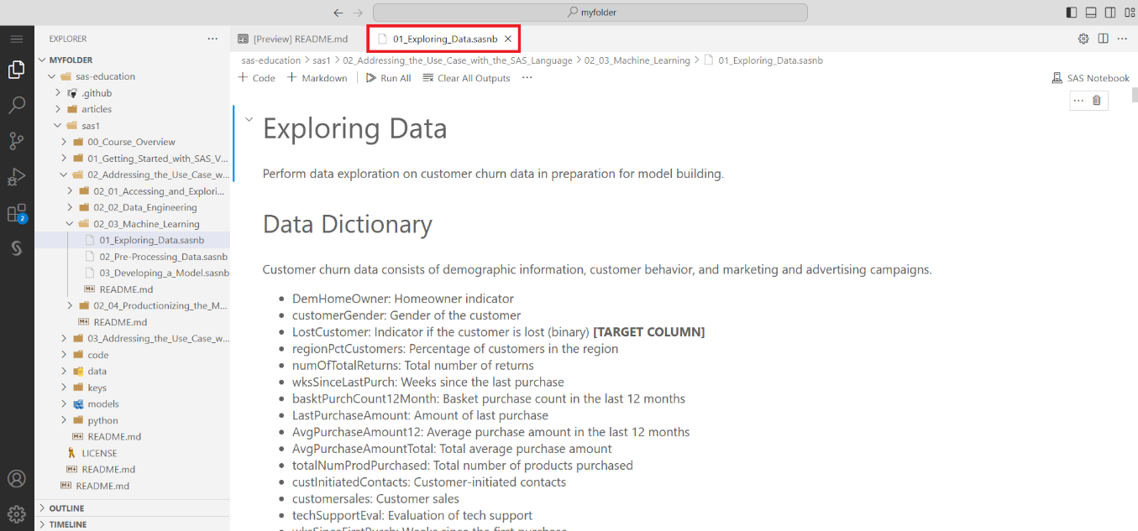
- Nice! Before we can run any of the code, we need to do one more thing. And that’s to adjust the location of the Input Data, found in this cell:
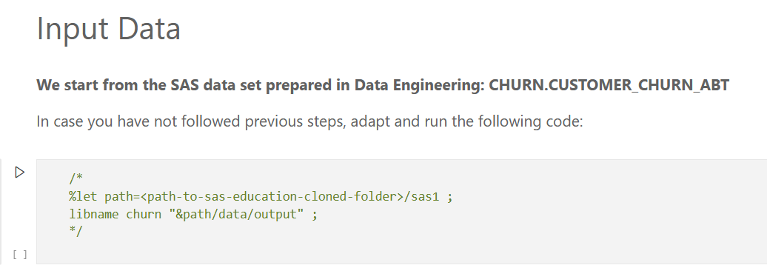
- Click on that cell. Then simply copy and paste the code below to replace:
%let path=/workspaces/myfolder/sas-education/sas1 ;
libname churn "&path/data/output" ;
- Then click the Execute Cell button, which yields – hopefully – a happy log… assuming you set up the Workbench as described above:
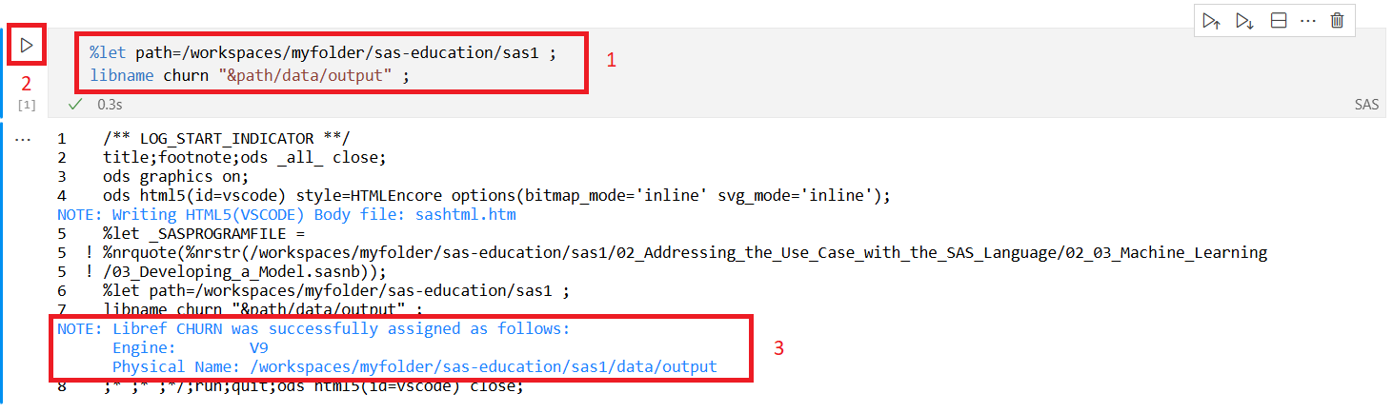
- Now, there are a couple of ways to continue this “course preview” party. You can simply click Run All… and run all the code, scroll to absorb some random content, and then just move on to the next program. That magical Run All button is found here:
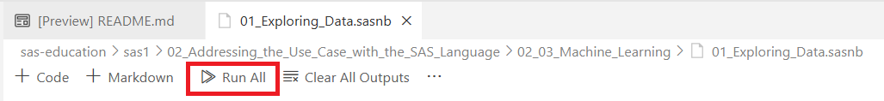
- Or… you can actually walk through the program as a “true” learner, which means running the program cell-by cell. This requires navigating to a cell, finding the little Play button, and mashing each and every one of those:
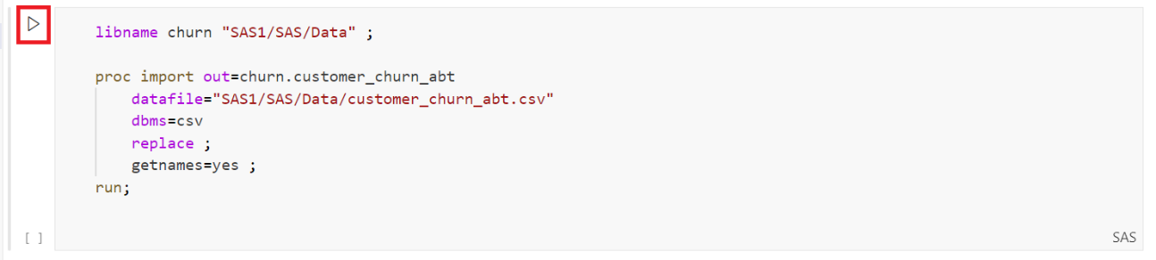
- For those not in the know, “mashing” is a southern verb meaning “to push”. Local dialects aside, the goal here is to show you an end-to-end data science project – done with two approaches – once in SAS and once in Python. And, as noted, we’re leading with SAS.
- Once you’re happy with exploring the data, know that we’ve got 5 more programs to explore: 2 SAS notebooks and 3 corresponding ones for Python. Because we’re going to do (roughly) the same thing in both SAS and Python.
- But… I’m not going to simply “punt” and say “have at it”. At the very least I can show you the code in each program that replicates something we did earlier in this SAS Guided Demo. So, in 01_Exploring_Data.sasnb, find the code on Histograms. It appears like so:
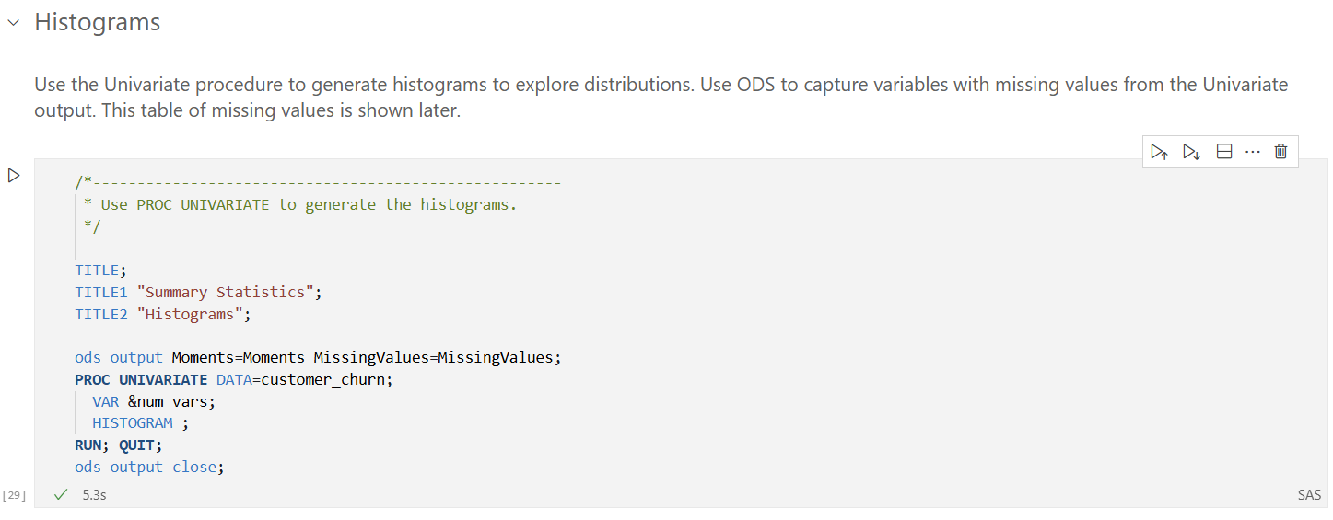
- This code replicates the bar charts created earlier in SAS Visual Analytics. And a WHOLE lot of other things. Get those scrolling fingers ready and scroll down the input to Distribution of customerAge. I see the following:
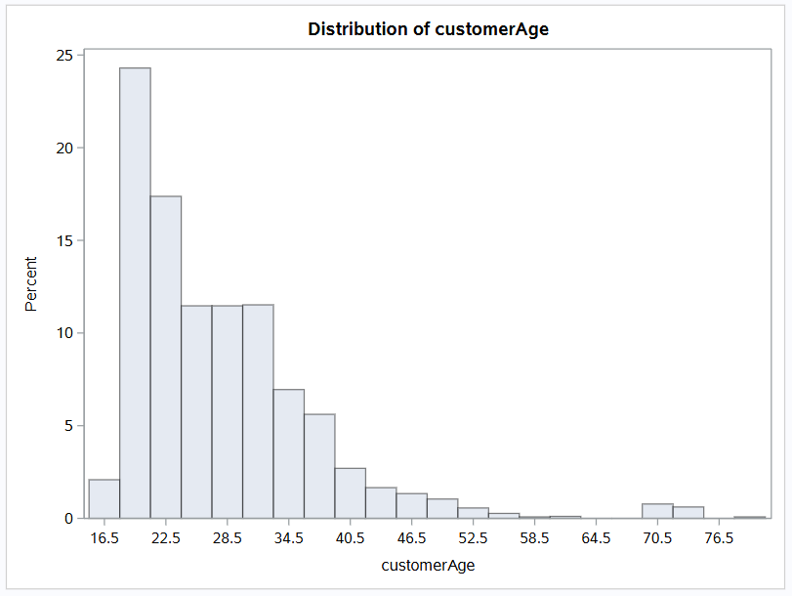
- What in the what? That’s a bit different than our findings in the VA report:
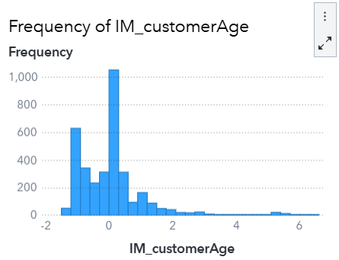
- But… fret not! The age variable still needs to be processed in the SAS notebook – meaning we need to (1) impute missing values and (2) normalize the variable for modeling. And we’ll get there in 02_Pre-Processing_Data.sasnb. So wait for it
- Explore the data a bit more. For example, here is a heatmap of the correlation between select variables:
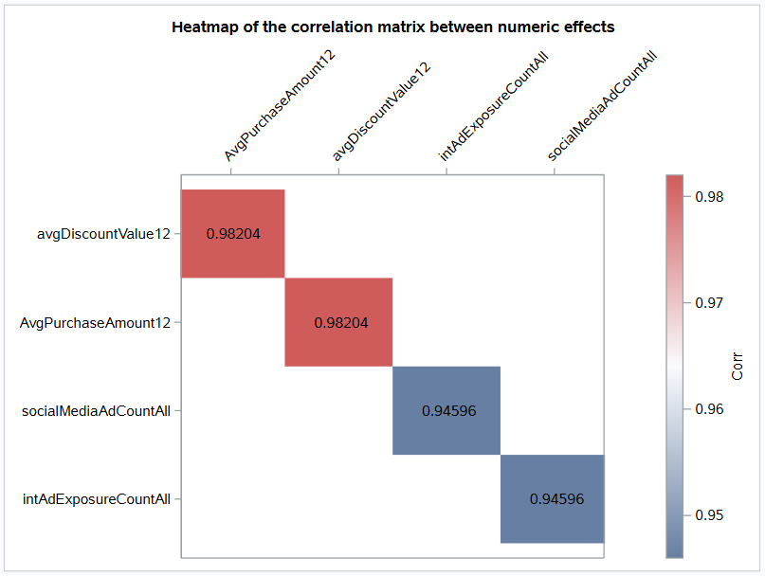
- That’s kind of fun! When you’re done exploring, move over to 02_Pre_Processing_Data.sasnb. In this notebook, we’re going to transform the data to get it closer to the data we examined at the outset in SAS Viya, which includes imputation and addressing outlier observations. You’ll also see that we partition the data and reduce the number of variables available for modeling via variable reduction. Then, we create that final dataset for modeling.
- Looking for fun output in 02_Pre_Processing_Data.sasnb? Well, there’s not a ton of options. But how about this table?
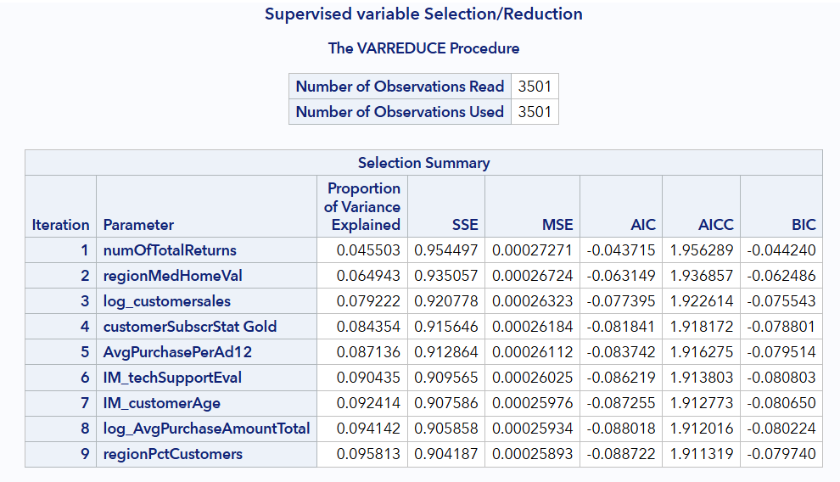
- Finally, open 03_Developing_a_Model.sasnb. Here we’re going to run A LOT of models to best determine which customers will churn at SASe. For example, here is the code for a gradient boosting model:
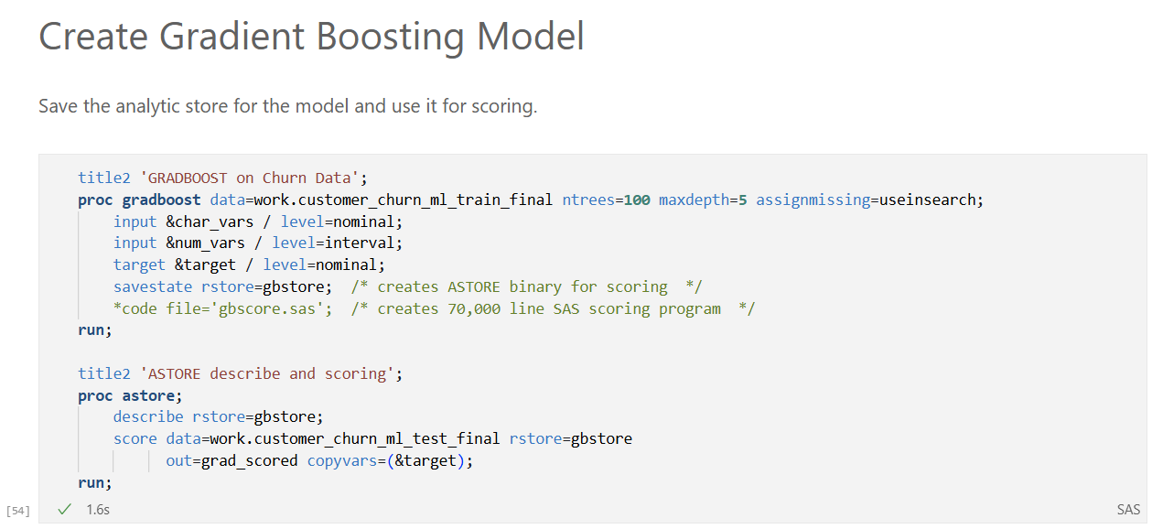
- And there is a whole lot of output to digest, including a useful variable importance table:
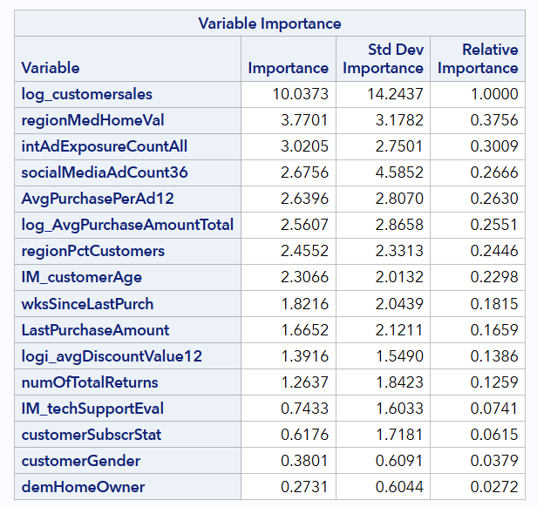
- Finally, a big part of predictive modeling and machine learning is comparing models and then selecting a champion model. Scroll down to the bottom to see the Model Assessment code. It’s a (coding) mouthful:
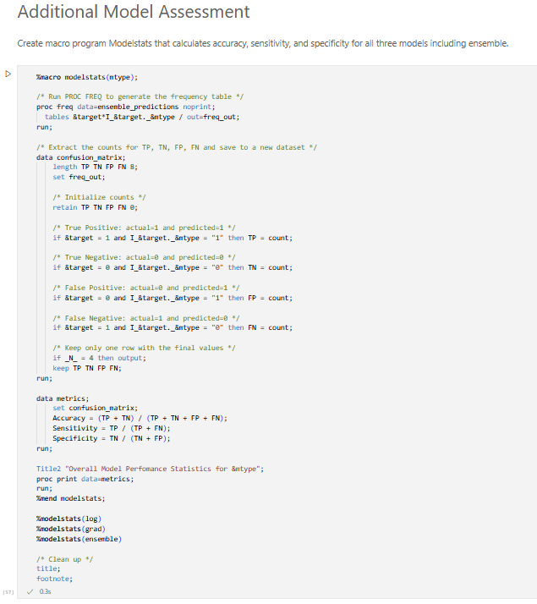
- And the output:
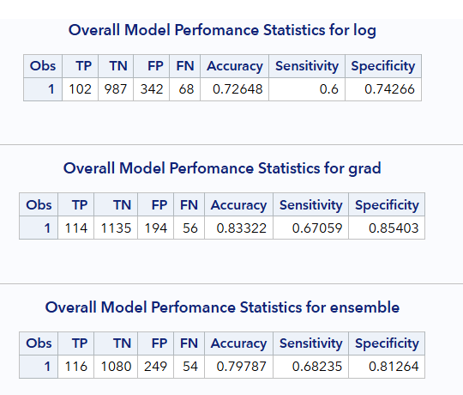
- Why would I put you through all that? Just to show you that the gradient boosting model would be selected if Accuracy was the selection statistic of choice? Well… kind of. I also want to show you the full code so that you can see the beauty and power of the code… and how flexible your program can be. But… it comes at the expense of time and expertise… as it takes a long time to master this code. That stated, you can do it – and the learning paths at the end will help! But, for now, let’s slide over to the Python code

Modeling in Python
You just saw how to explore data, pre-process data, and then model in SAS using SAS notebooks in Visual Analytics in SAS Viya Workbench. Yes, that was a mouthful. But, word-jumbo aside, let’s show you how to do it all again in Python.
- Since I’m a teacher at heart, I’m going to expose you to another Integrated Development Environment – aka IDE. Close the Visual Studio browser window and go back to the SAS Viya Workbench landing page. And confirm that your session is still Running… because running is a good thing. It means the session is still active:
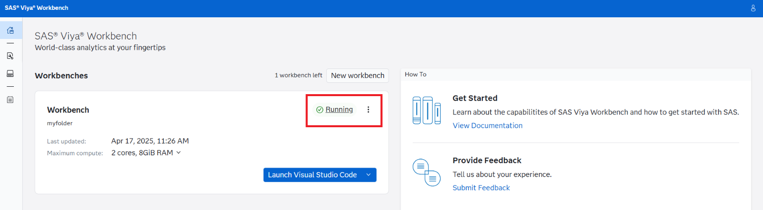
- Now examine the Editor options next to the Launch Visual Studio Code button:
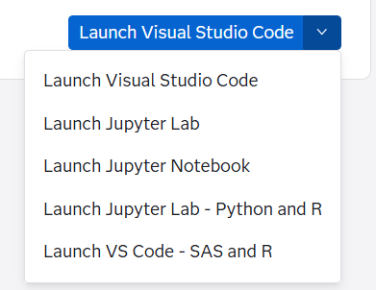
- Lookie what we have there! For those looking for a Jupyter experience closer to the one provided by default in SAS Viya, I recommend using Jupyter Lab.
  - And for those of you interested, my good friend ChatGPT has this to say about the difference between Jupyter Notebook and Jupyter Lab:
  - “Jupyter Notebook offers a simple, single-document interface where you work on one notebook at a time, making it ideal for focused tasks. JupyterLab provides a more flexible, IDE-like interface that allows for working on multiple documents and tools simultaneously, with customizable layouts for enhanced productivity.”
- So, open Jupyter Lab for today, because we’ve got multiple programs to look at. And you’ll likely get this message:
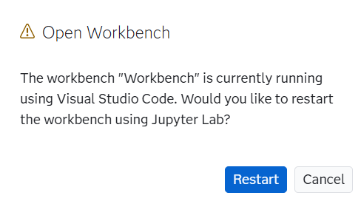
- All good, let’s Restart! And then Welcome to Jupyter Lab!
- Now we already did the hard work of setting up the data and notebooks in Visual Studio. So, to find the Python programs using the File Browser, drill into sas-education >> sas1 >> 3_Addressing_the_Use_Case_with_the_Python_Language >> 03_03_Machine_Learning. Like so:
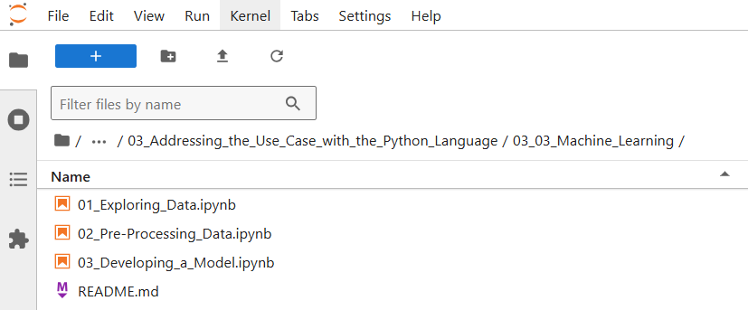
- And the corresponding notebooks await. Nice!
- Even though we’re in a second IDE, the actions are the same:
  - Open the notebooks in order.
  - Run them… either as individual cells or as entire programs.
  - Digest as much of this Machine Learning section as you can handle in one sitting.
  - And, finally, more high fives – you’re done.
- But, again, I won’t just leave you at that. Let’s explore some of the same items we examined in the Modeling in SAS section. So, open 01_Exploring_Data.ipynb, which reveals:
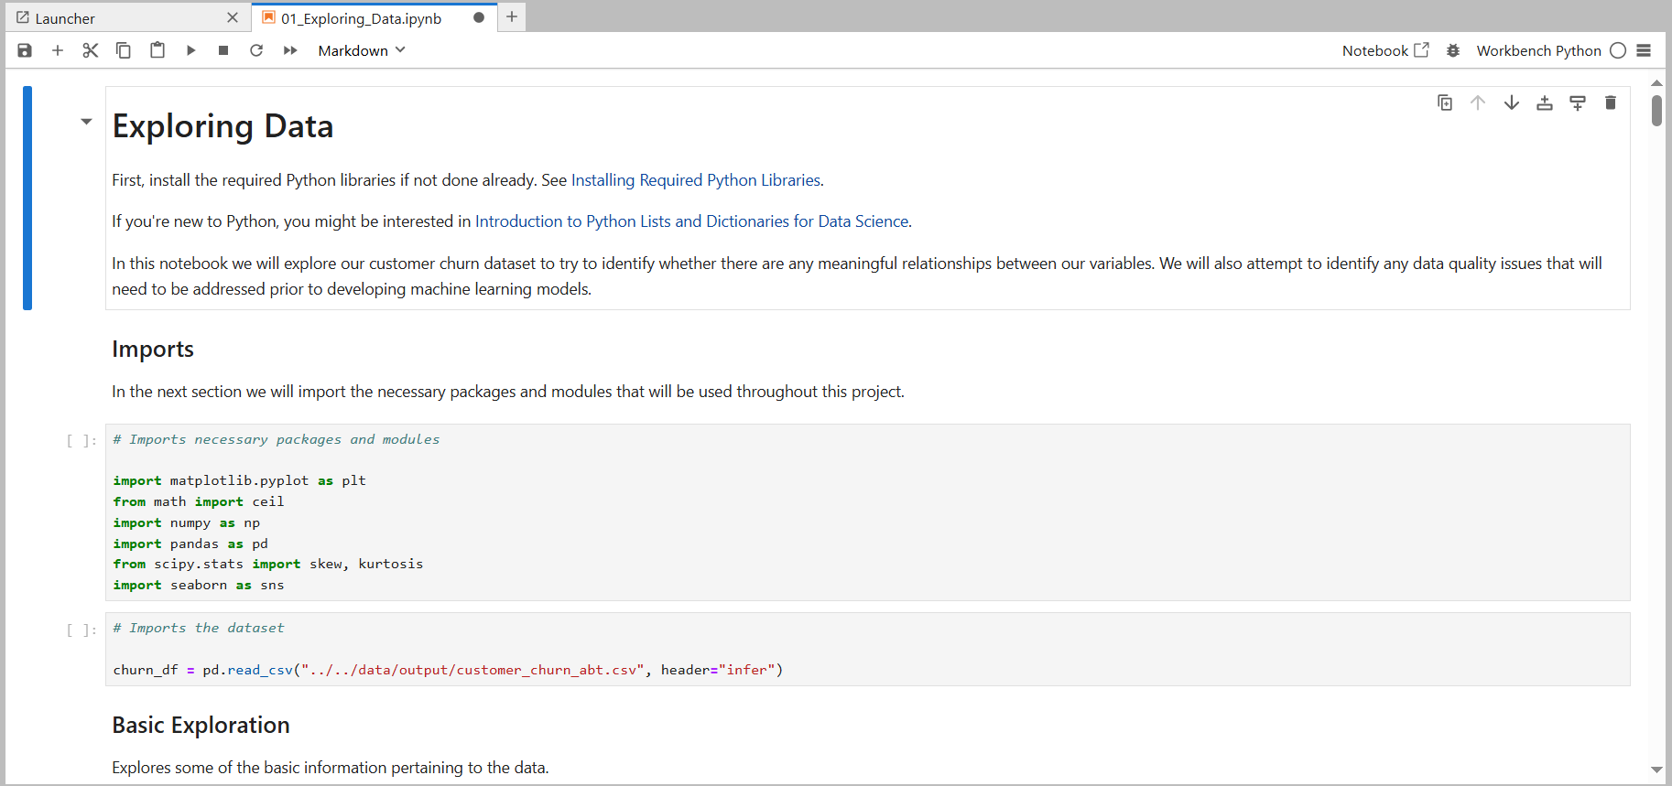
- In Jupyter, you can either select Run >> Run All Cells or select an individual cell and then submit with a Shift+Enter. I’m going to Run All Cells just to simplify my storytelling:
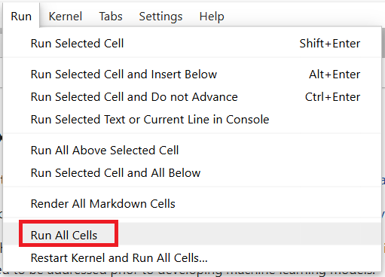
- Scroll until you find the code for the Histograms:
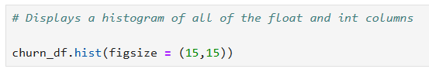
- Pretty succinct code, eh? And check out the output table:
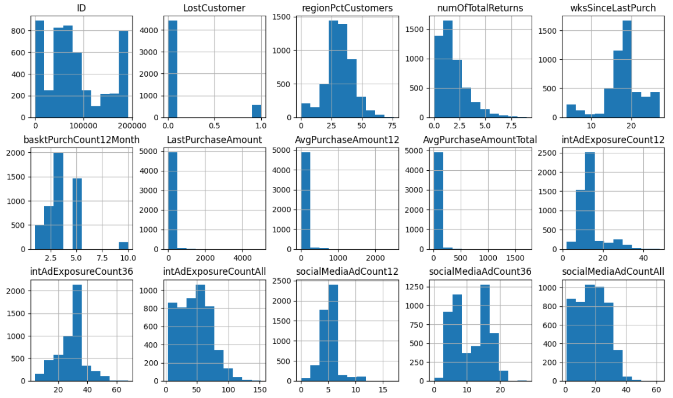
- That’s a great way to digest the information! Points for Python! Moreover, here is the code and output for the LostCustomer variable analysis:
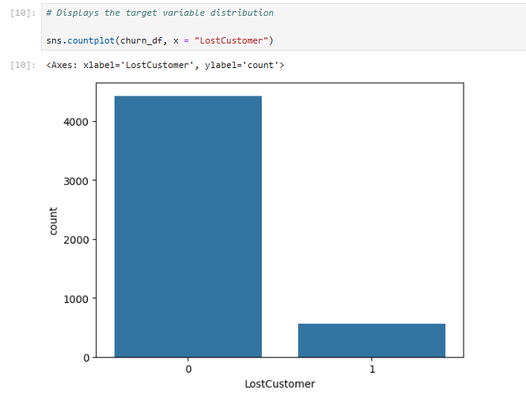
- Python is a lower-level language than SAS – meaning that you need to do a lot more coding to get output. But, that does have advantages when you just want something simple. For example, here is another easily digestible table:
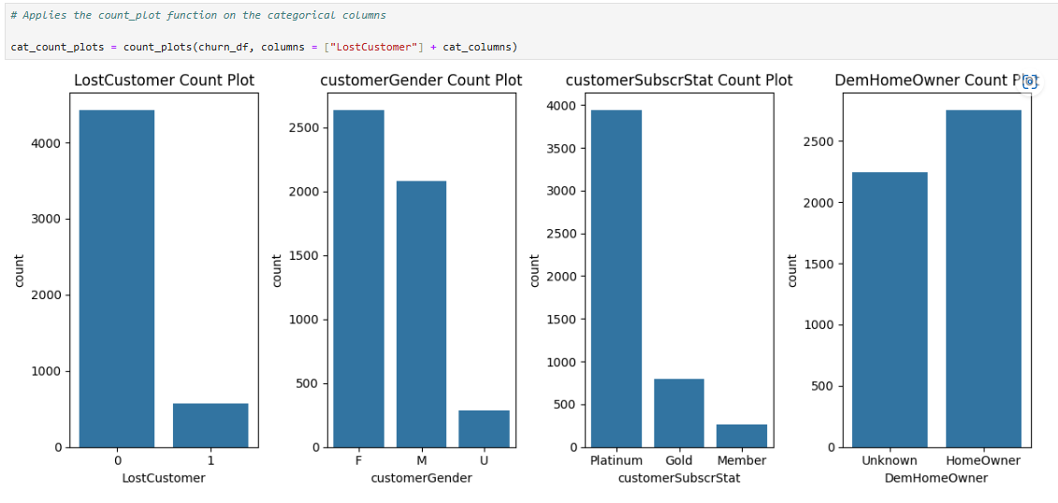
- My point: every language does some things very well – so learn as many as you can so that you can use the right tool for the job! And after absorbing those words of wisdom, check out the HeatMap, with some useful correlations:
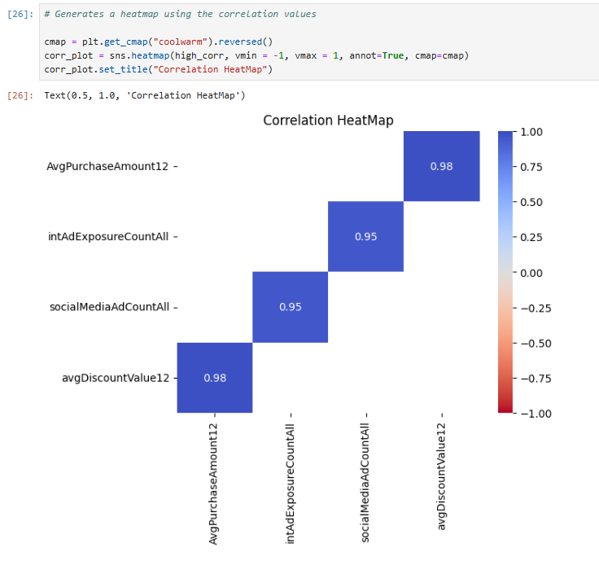
- Alright, that was fun. Open 02_Pre-Processing_Data.ipynb to keep the adventure rolling. Submit and explore that code, which will partition the data, impute missing values, address outliers, and reduce the number of input variables. Note that the last part can take a bit of time because it uses a compute-intensive backwards elimination tool!
- And here is a summary of the variables selected:
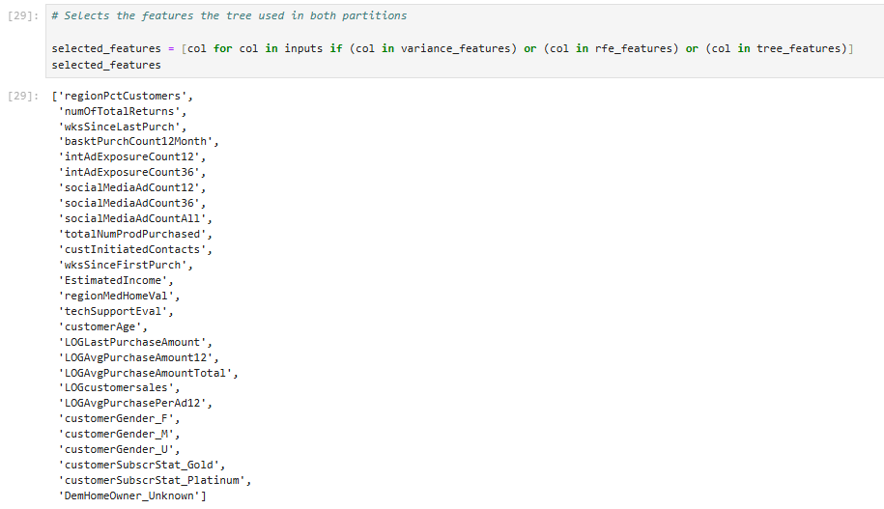
- Mheh. I’ve seen better summary tables. But that works.
- Alright, what do we have: (1) data read in. Check. (2) Data cleaned. Check. Now let’s open 03_Developing_a_Model.ipynb and explore some models! That notebook:
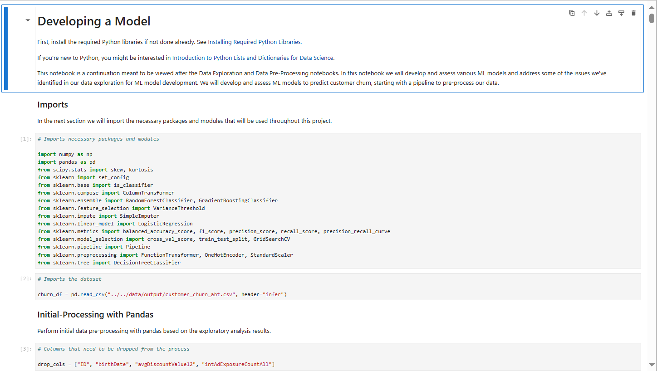
- As noted in the preamble, we’re going to use the sklearn packages to run a series of predictive models. Moreover, one special feature in this notebook is the Hyperparameter Tuning code, found here:
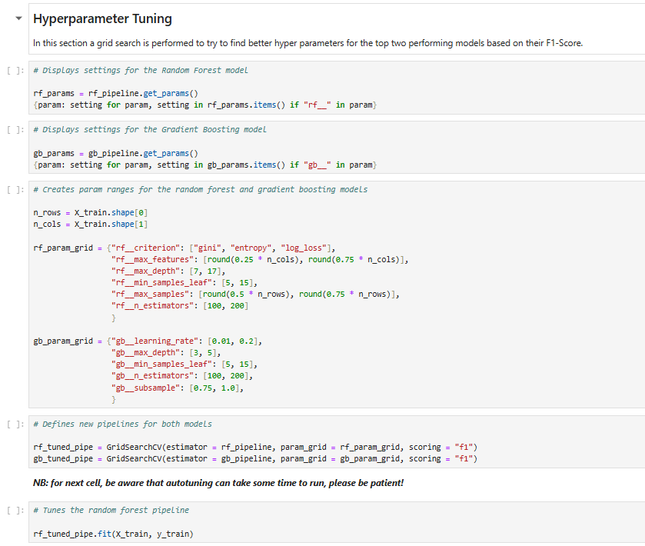
  - What is hyperparameter tuning… aka autotuning? Well, it is machine learning in the truest sense: it means the machine will run thousands of different models, based upon combinations of settings (or hyperparameters) in the models. In our case, the machine will iterate on the random forest and gradient boosting models. As a more concrete example for tree-based models, hyperparameter tuning will adjust the number of branches available, the depth of the trees, the decay rates, etc. all automatically. Whoa. And if you’re not sure what that all means – don’t worry – there is a SAS course for that!
- 03_Developing_a_Model.ipynb will take a long time to run because of the autotuning, a bonus feature in that notebook not currently available in the SAS code (but wait for it!). Once finished, you’ll see that the assessment tables are a bit buried. But the selected model has the following performance measures:
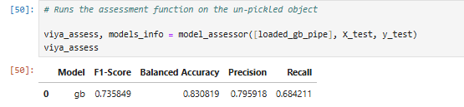
- Digest all that output for a bit. Then exhale. Our coding adventure is over. Now let’s return to SAS Model Studio in SAS Viya for Learners and see how we’d do a similar analysis in a low/no-code environment.

SAS Model Studio, Revisited + Expanded
Let’s face it. We’ve done a LOT already. And, yes, I’m going to plunge full steam ahead and show you how SAS Model Studio does pretty much everything we did… with just a few clicks. SAS Model Studio is a prime example of how SAS is embedding AI agents throughout the analytics lifecycle – which helps speed up the analysis time. In the past data scientist could expect to spend roughly 80% of their time preparing data and just 20% doing the good stuff – i.e., modeling and deploying models. However, with no + low-code tools, we can spend a LOT more time running models, working on the storytelling, and then asking whether we should be running those models – aka ethical data analysis. It’s a brave new world indeed with AI!
Let’s get back into SAS Model Studio and examine our pipelines.
- Log back into SAS Viya for Learners, if you timed-out. Timeouts happen. And if you’re no longer in SAS Model Studio, you can get there via the Applications menu:

- Click that button and then select Build Models:
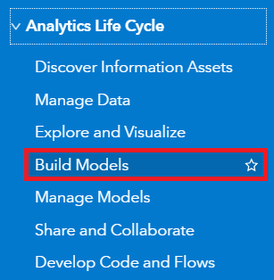
- And if you really need to, open your SASe Customer Churn project. I’m hoping that it’s still active. Additionally, return to the Interactive-Model Pipeline, here:
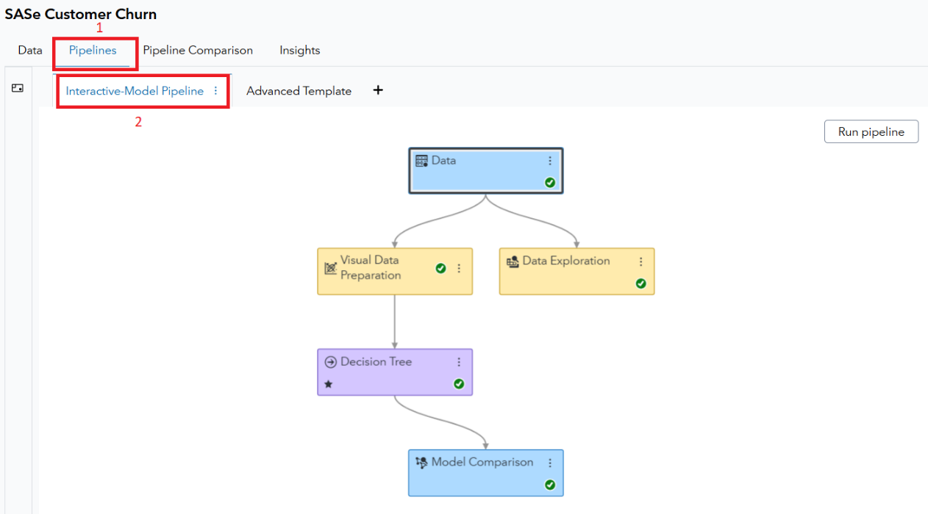
- Green checkmarks mean that modeling life is good! We’ll start our SAS Model Studio digest in the Data Exploration node. Right-click on the node and then select Results, like so:
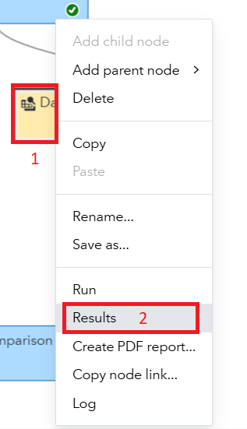
- What do we have here? Well, well – a LOT of useful information on our data! Remember we had to either code or create this in a dashboard in our previous work. But with one node, I get helpful information like Class Variable Distributions:
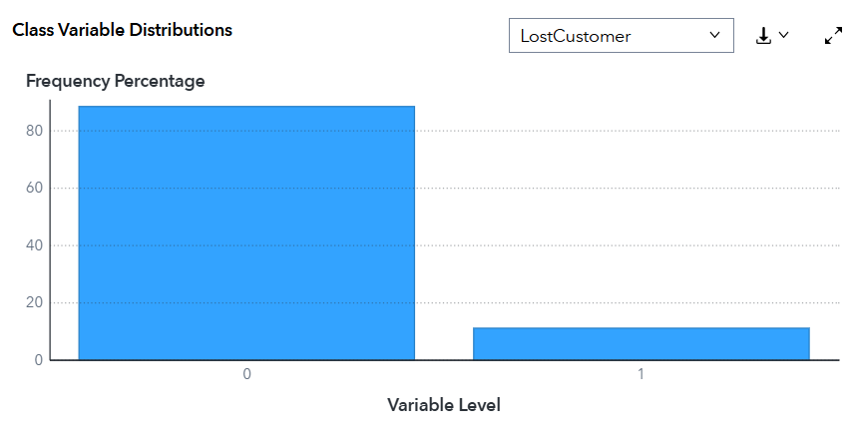
- And, wait there’s more! Check out the correlations with fun phrases like “Symmetric Uncertainty”:
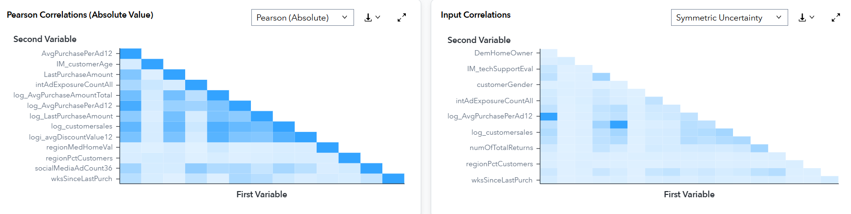
- Anyway, there is a lot to digest here. Digest away and click Close when you’re done. Bonus points for downloading a PDF and sharing with your family. Those two buttons are found here:
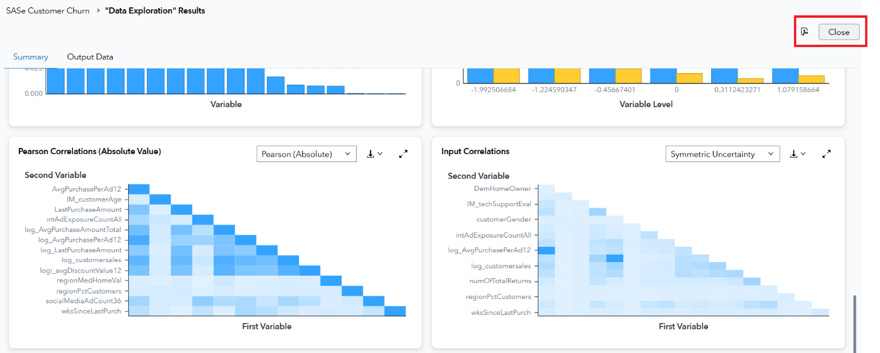
- Now let’s examine the decision tree that we imported from SAS Visual Analytics. Right-click Decision Tree in this pipeline and then select Results. With these two steps:
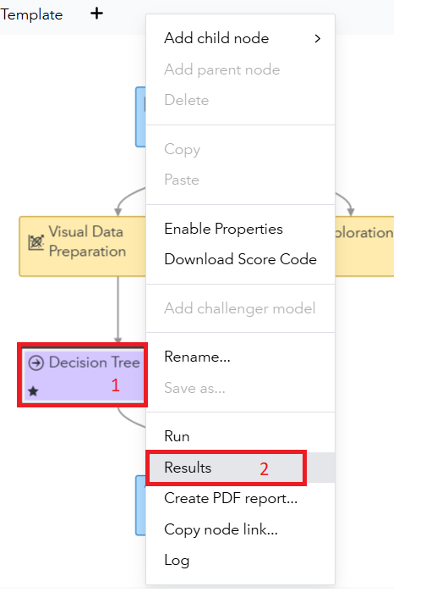
- Another interactive dashboard thing awaits! And you land on the Node tab:
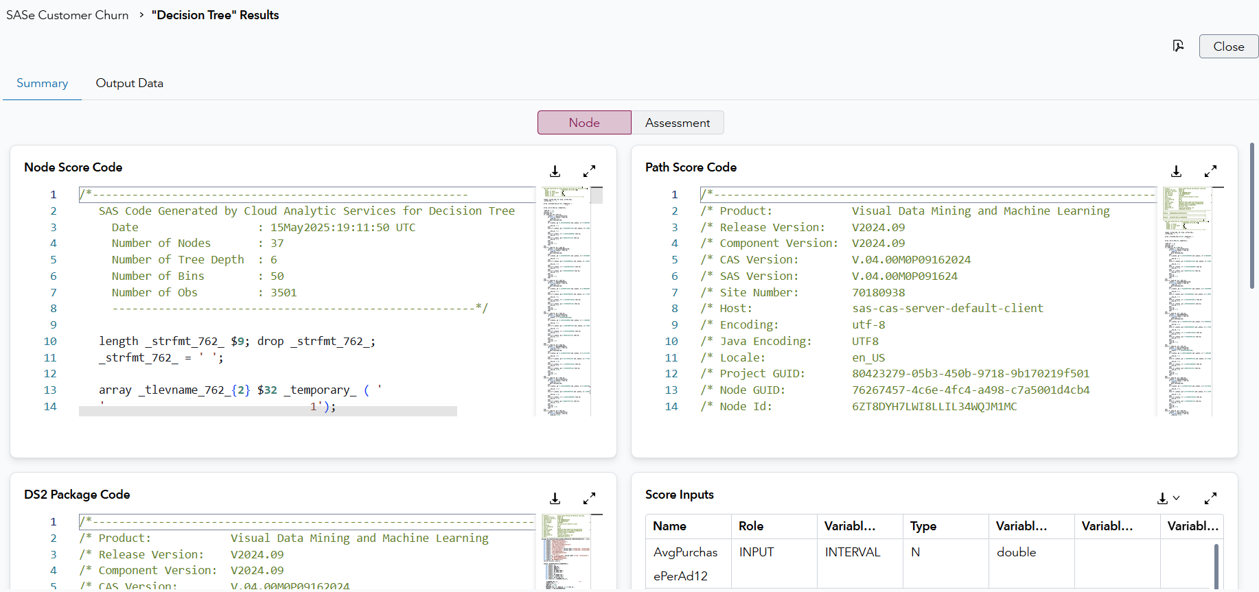
- Click Assessment so we can see how the model performed:
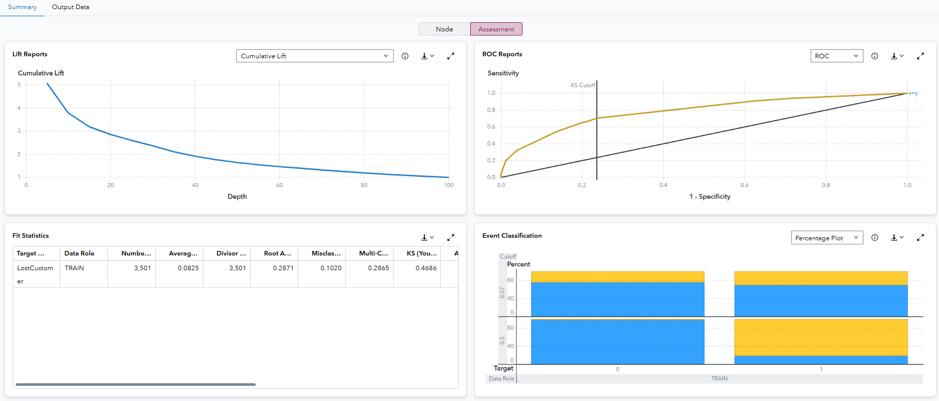
- Here you’ll find a lot of assessment tools to see how well your models fit the various data samples. Explore for a bit and then pause to think: if you were to program all this, how long would it take you? For me… a little bit
- Click Close when you’ve processed the Results for the Decision Tree. And the same bonus points apply for creating a PDF and sharing with family.
- Alright – that’s one pipeline… but what about the Advanced Template. Wasn’t that a big deal? Yes, yes – it was. Activate that pipeline and ensure that you’ve got a bunch of green checks:
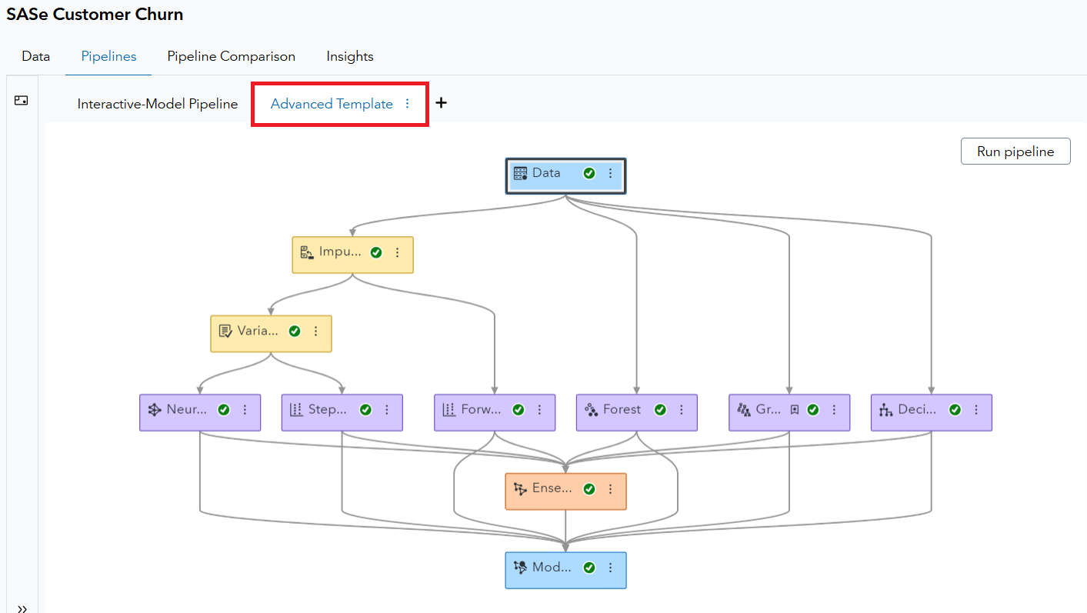
- Remember that there are 7 models in this pipeline, including the Ensemble which is based on the estimates from the previous 6 contenders. And while you could explore the models individually, you’re bound to think: which model is the best? And there’s a node for that! Right-click on Model Comparison and then select Results, as follows:
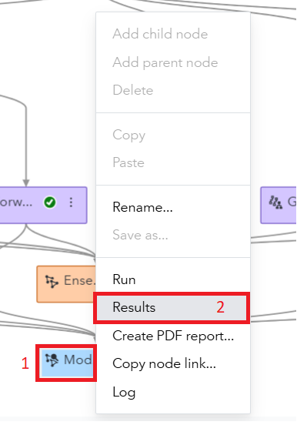
- Look how nicely those results are displayed! And we can quickly see that the Gradient Boosting model is chosen, with the default selection statistic of the KS(Youden) statistic:
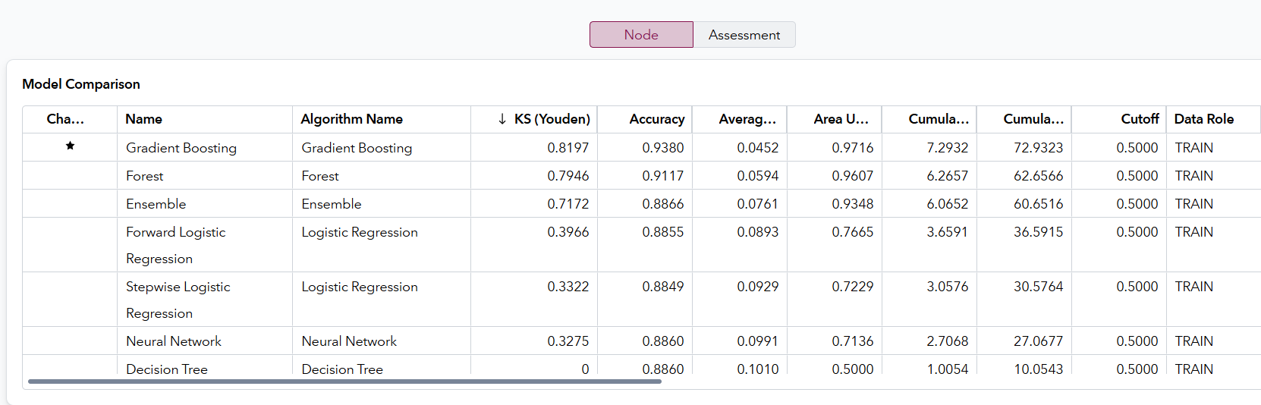
- Additionally, the Assessment tab allows you to compare the model based upon other statistics, such as Lift Reports and ROC Reports:
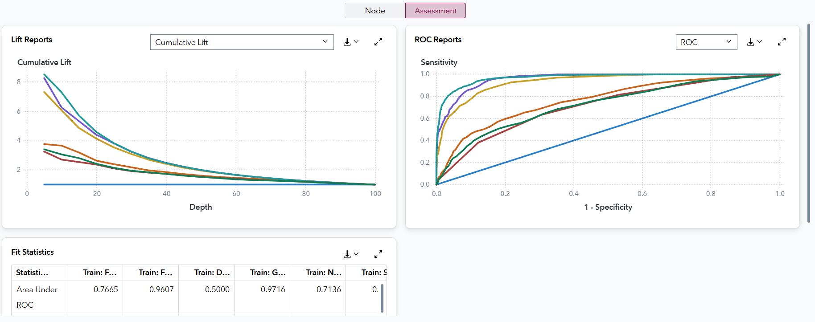
- And I’ll ask the question again. How quickly could you code those model comparisons. Me? Well, that would take a LONG time! Explore the Results a bit and then click Close.
- Two more things to show you before we wrap up. We have two pipelines… but we haven’t crowned an overall project champion. And that information is waiting for you under the Pipeline Comparison tab. Check it out:
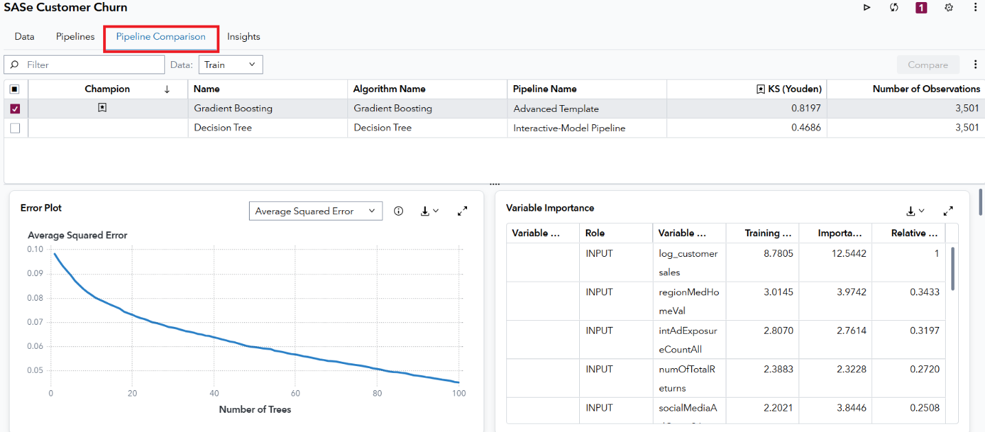
- You see what I see? Yes, your eyes are not deceiving you. The Gradient Boosting model crushes that Decision Tree from VA. Next step would be to put that model into production – which means identifying the current set of customers who could be on the cusp of canceling. Then we can pass that list on to marketing and let them custom-tailor promotions to keep them around. But that is a story for another day.
- The last thing I want you to explore is the Insight tab. It’s found here:
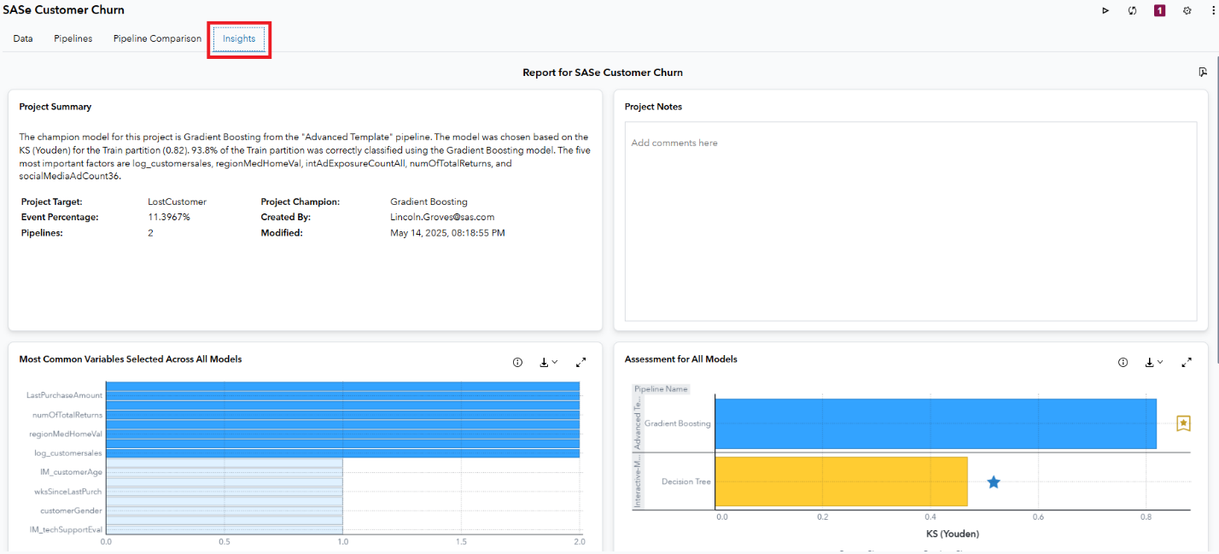
- Insights are a series of AI generated summaries which help you explain your data to a broader audience. Because modeling is often just half the battle. You then need to explain your results to other people. And that is another task for another day. But just explore for a bit and I’ll see you in the wrap-up section.

Wrap-Up and What’s Next.
Thank you for joining me on this Day 1 SASe adventure. Hopefully you got some good insights into the life of a newly hired Data Scientist in the Customer Retention Department at Styled and Sophisticated Enterprises. LostCustomer identification was our endgame and there were lots of twists and turns along that learning path – all while gaining exposure to the SAS Viya ecosystem!
I hope you’re thinking – that was a lot… but I really want to learn more! And, if yes, then I’ll return us back to the 4 recommendations that I have for you based upon questions you may be asking:
- Still confused and want to learn more about the SAS Viya ecosystem?
  - Take our SAS® Viya Overview course
- Like dashboarding and SAS Visual Analytics?
  - Explore SAS Visual Analytics 1 for SAS® Viya: Basics
- Like predictive modeling and machine learning in a low/no-code environment?
  - Machine Learning Using SAS® Viya® is a great option!
- Finally, love coding in a multi-language environment and want to explore SAS Viya Workbench more?
  - Modern Data Science with SAS® Viya® Workbench and Python is perfect for you!
For students, all of these courses are in the SAS Skill Builder for Students. And professors can get access via the SAS Educator Portal. And all academics get these courses for free.
Good luck – and happy learning!

